**UMBC**

**IS 722: Systems & Information Integration**

**Project Deliverable III: Integrating information from multiple repositories**

**TEAM 3**

**DUE BEFORE 2 DECEMBER 2020 4 30 PM**

1. **Demo.** **This is the major part. It shows all you have learned from the entire course. You will run the system in real-time and you will show the entire class the flow of certain scenarios (global queries) as they are passing through the system**. Prepare a script with the global queries and the appropriate calls. This script should start with DELETE commands, and then CREATE TABLE commands, etc. The script starts on a clean database, populates it, and runs the code. Make sure to show:
   1. **[15 pts] Global query.** The global query as a string
   2. **[55 pts]Subqueries.** Each subquery as it has been automatically generated by your system
   3. **[15 pts] Partial Results.** The temporary tables that contain the results for each submitted subquery to each local database
   4. **[15 pts] Overall result**. The consolidated result of multiple subqueries

**SOLUTIONS**:

**Scenarios exhibition: KEYWORD TABLE**

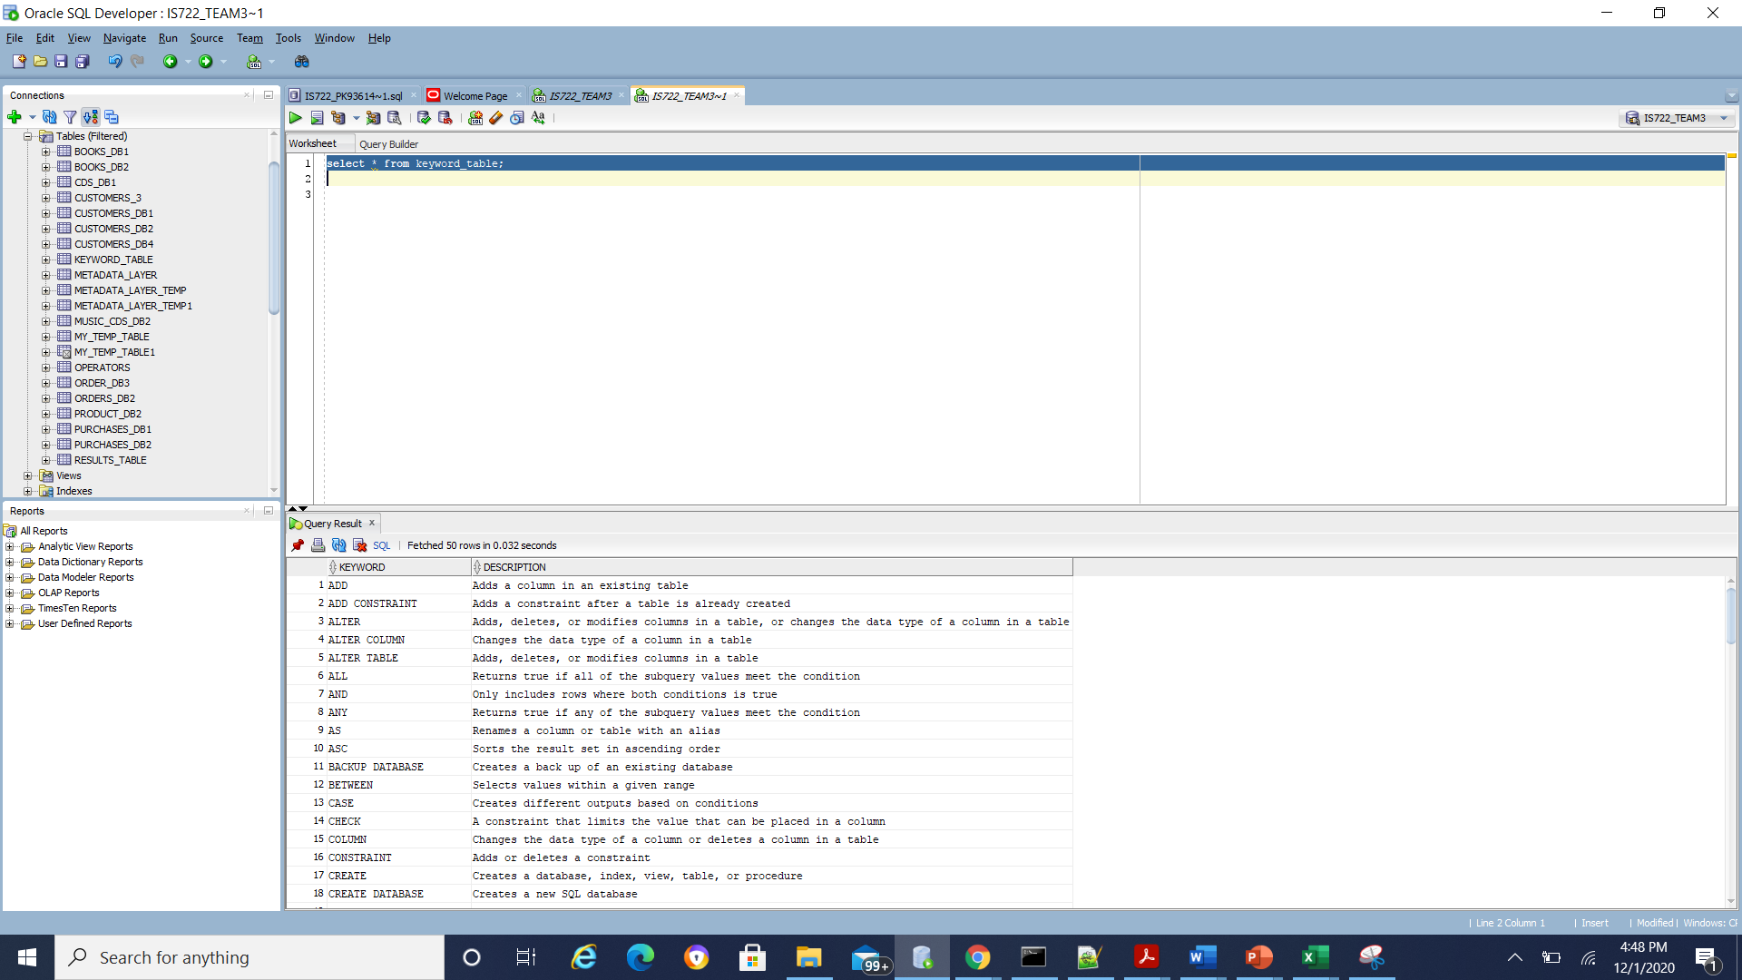

**Case 1:**Search for all books that have been authored by a specific author of your choice

**Input query**:

A) GLOBAL QUERY

'SELECT book_title FROM books_db WHERE author_first = ''Philip'''; ( global query)

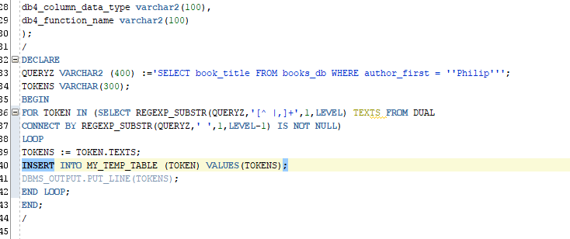

Tokenizer output:

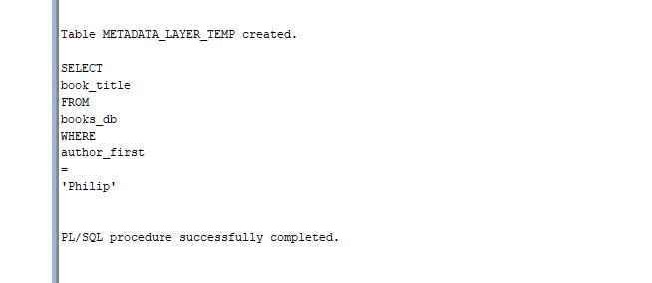

**b) SUBQUERIES OUTPUT: FROM ALL LOCAL DBS 1,2,3,4 RESPONSES**

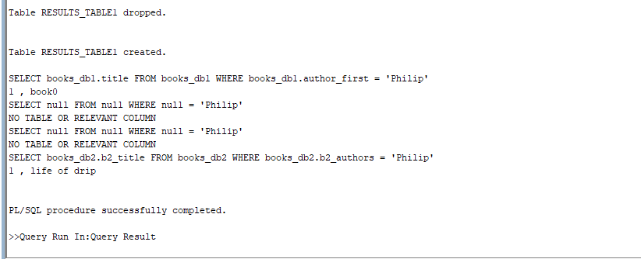

C) PARTIAL RESULTS:

Temporary table 1:

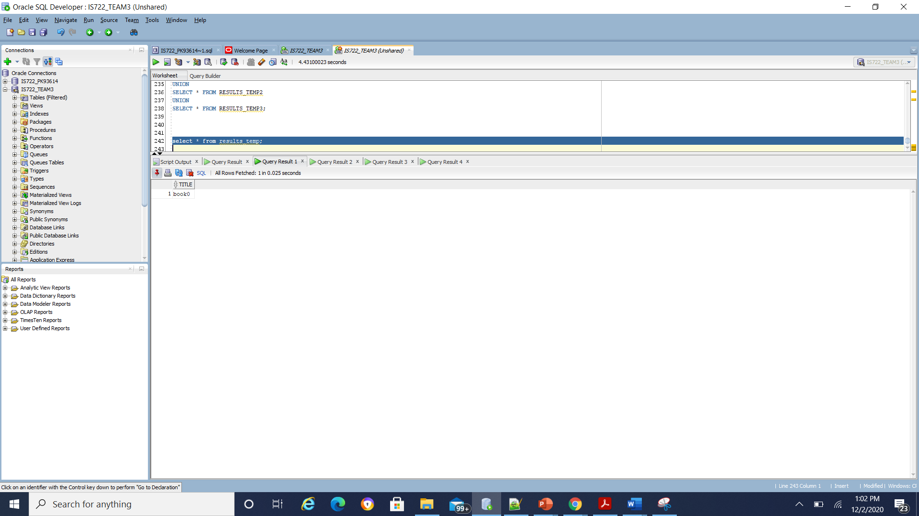

Temporary table 2:

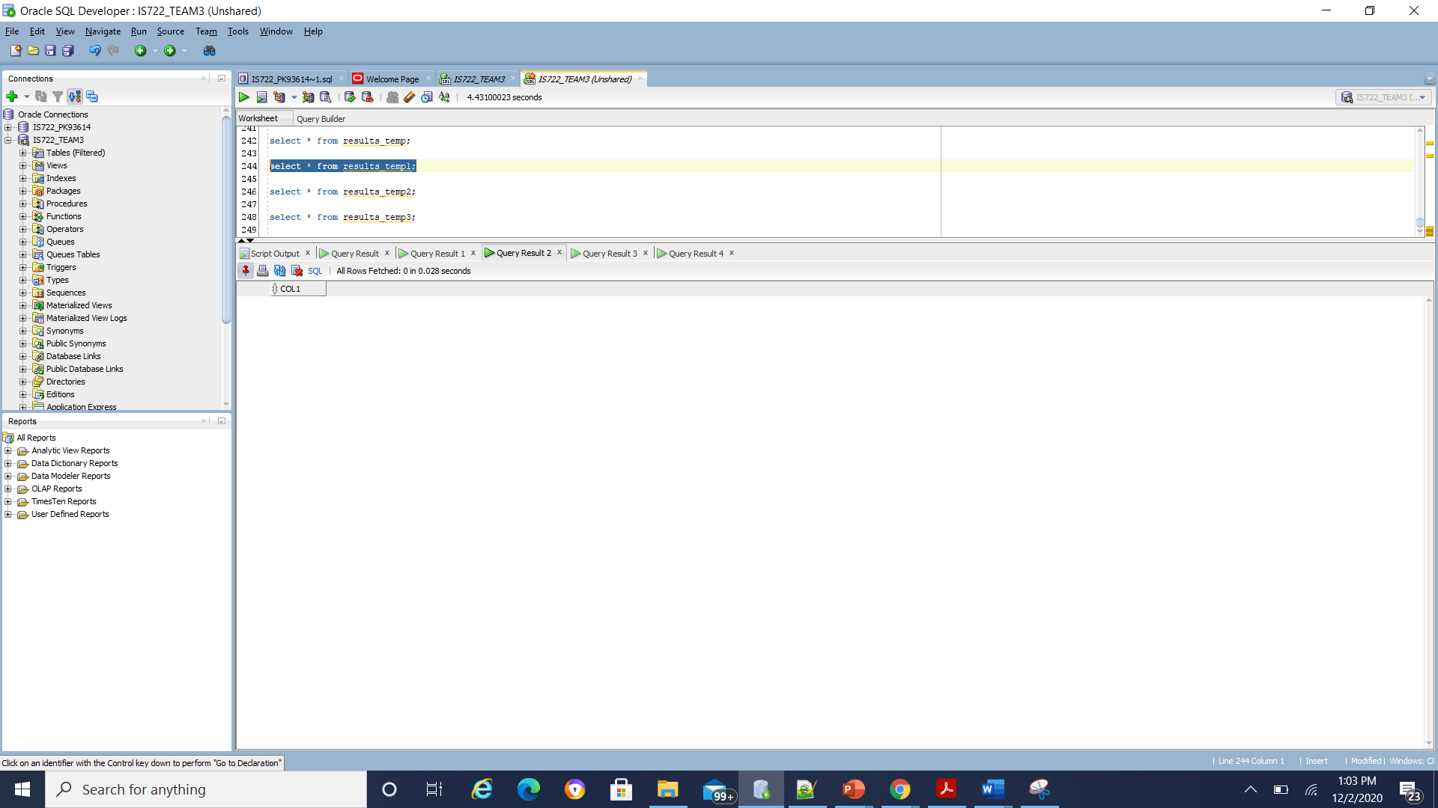

Temporary table 3:

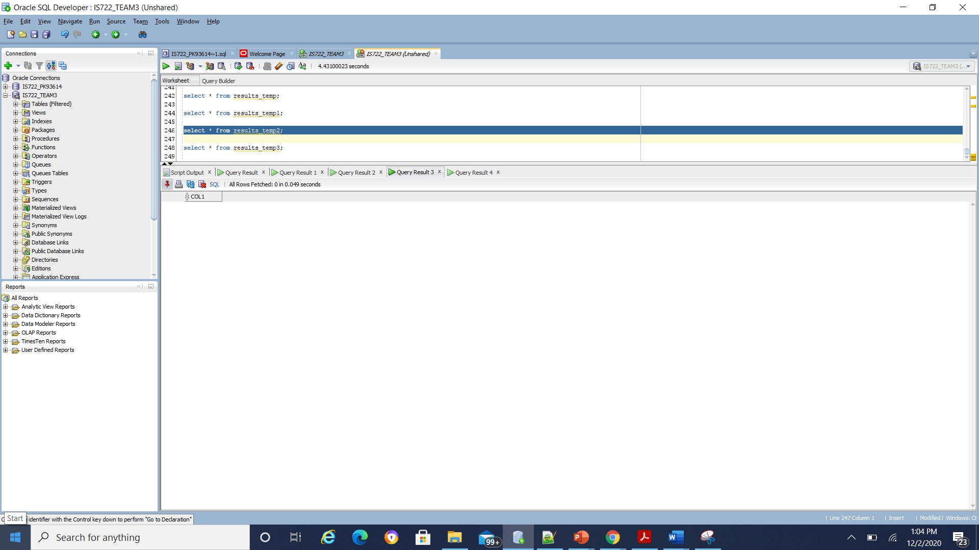

Temporary table 4:

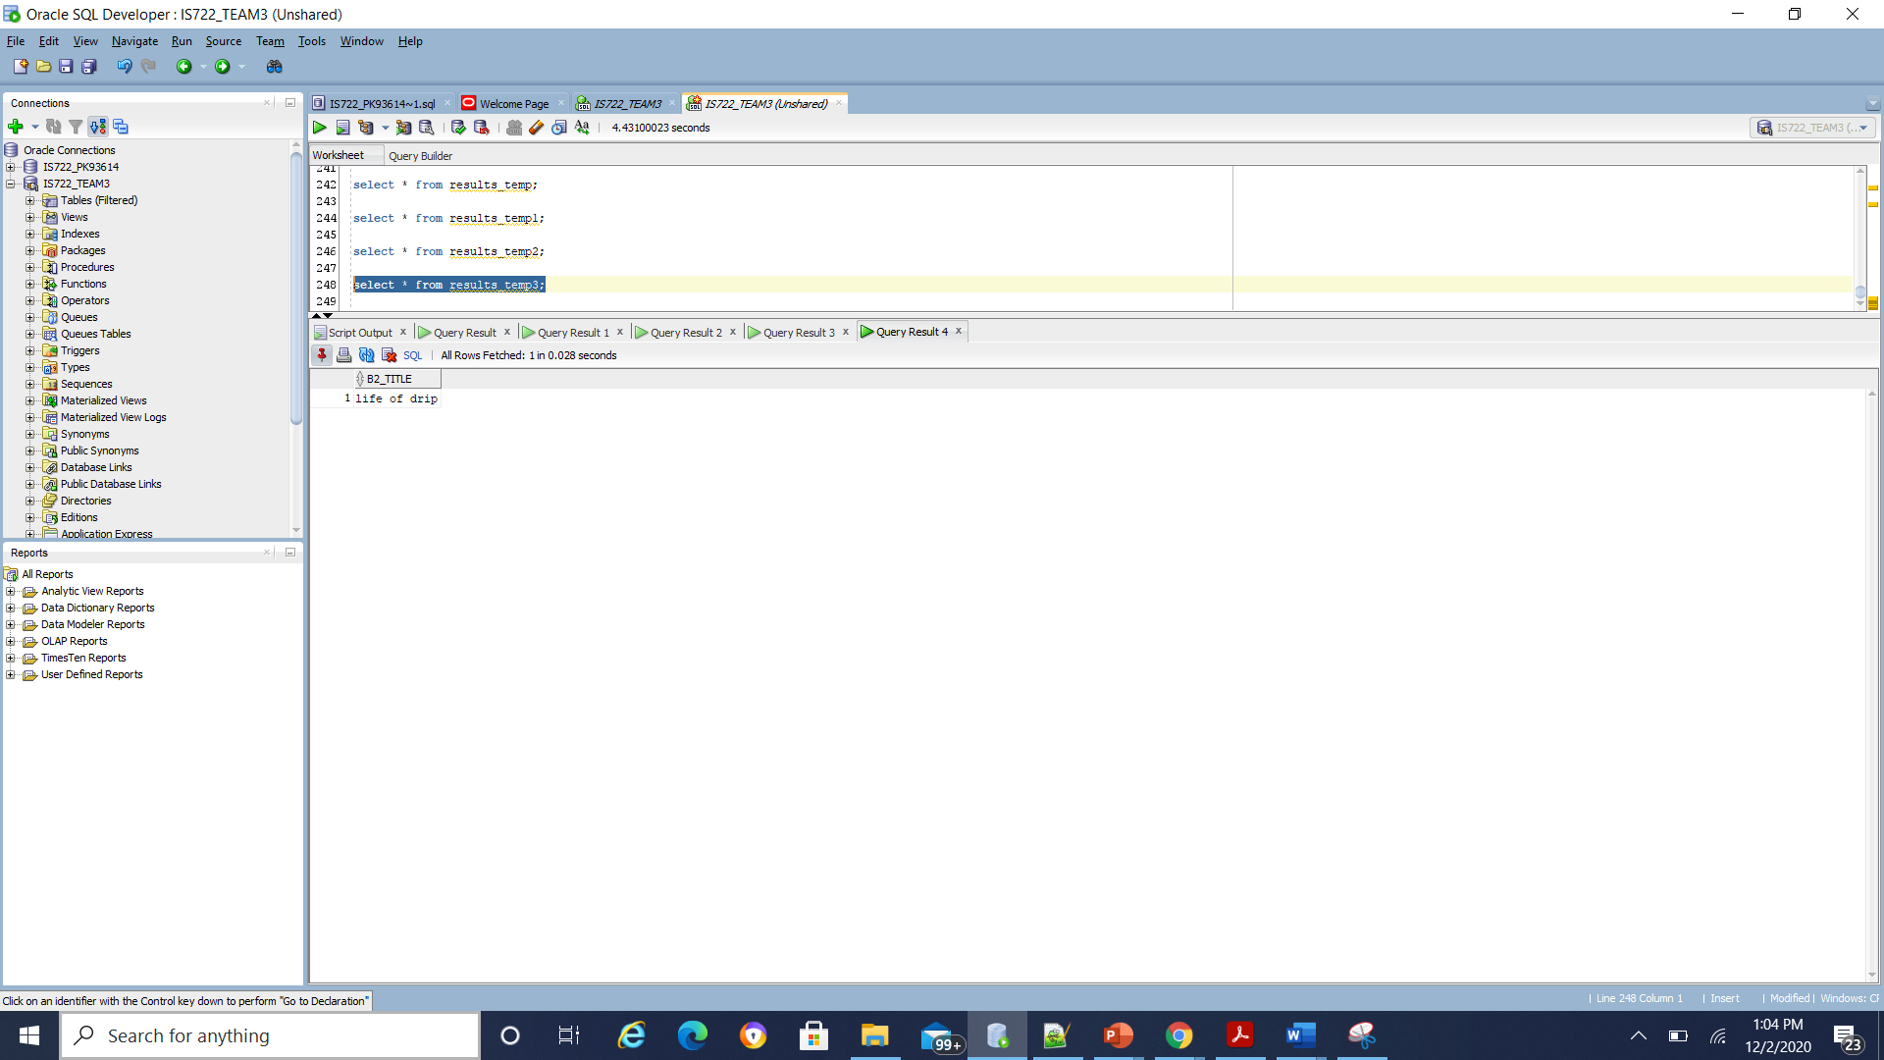

**D) CONSOLIDATED QUERY:**

**Put together the results of the subqueries by using a UNION operation. Make sure you have union compatible results to demonstrate this case**

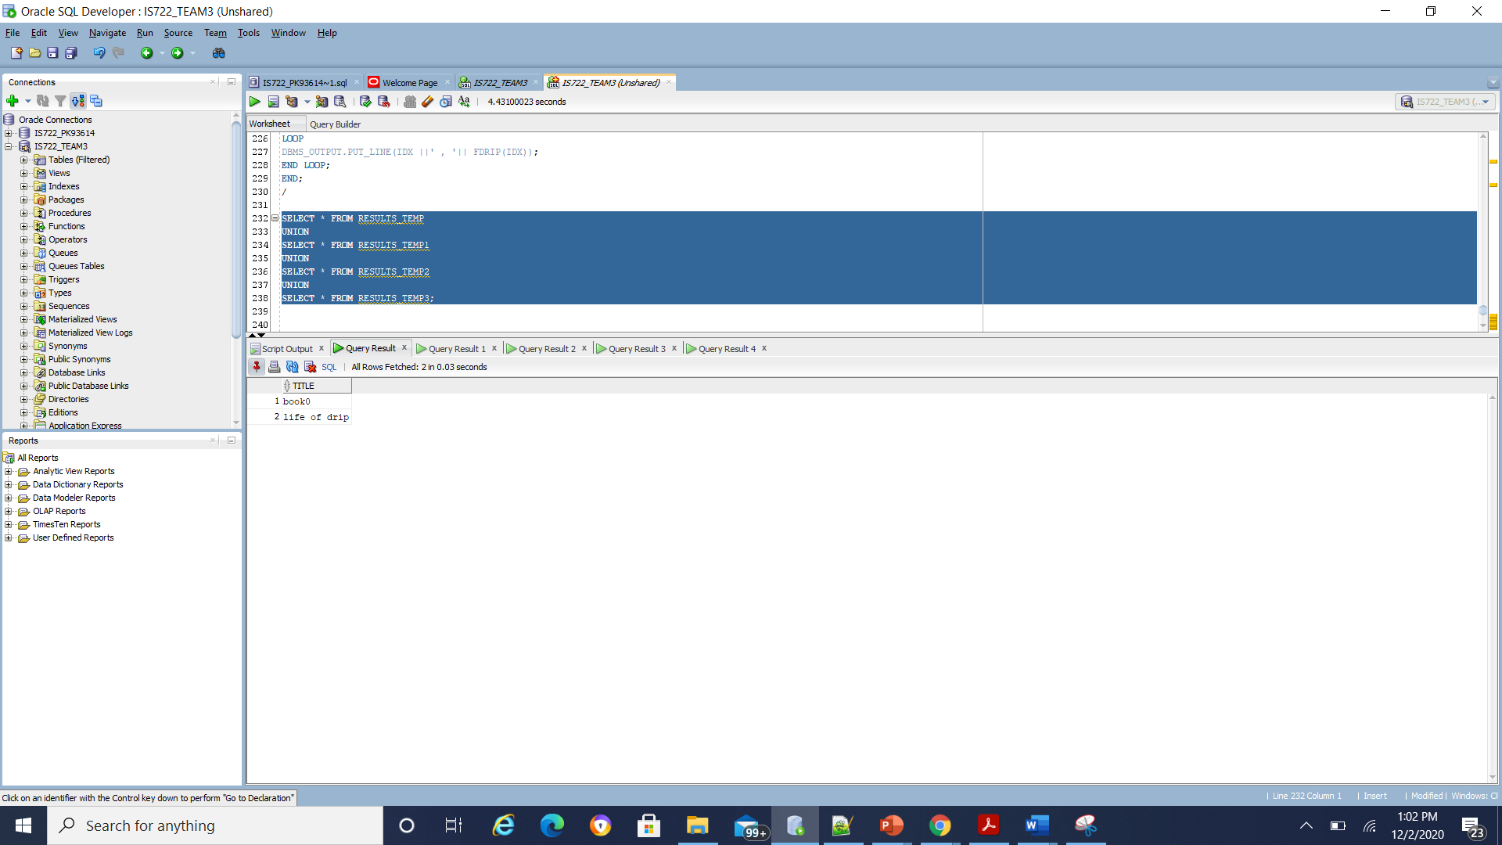

**Case 2:**Search for all CDs that feature a specific artist

**Input query**:

A) GLOBAL QUERY

'SELECT cds_title FROM cds_db WHERE artists = ''lil_baby'''; ( global query)

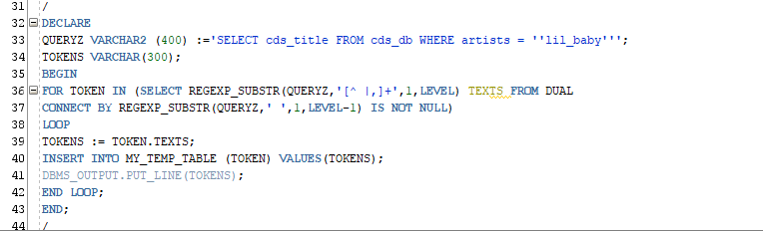

**Tokenizer output:**

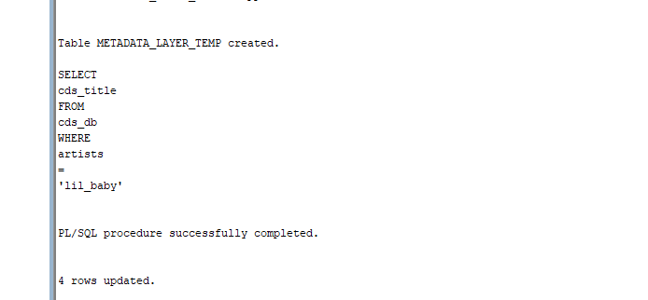

**b) OUTPUT: FROM ALL LOCAL DBS 1,2,3,4 RESPONSES**

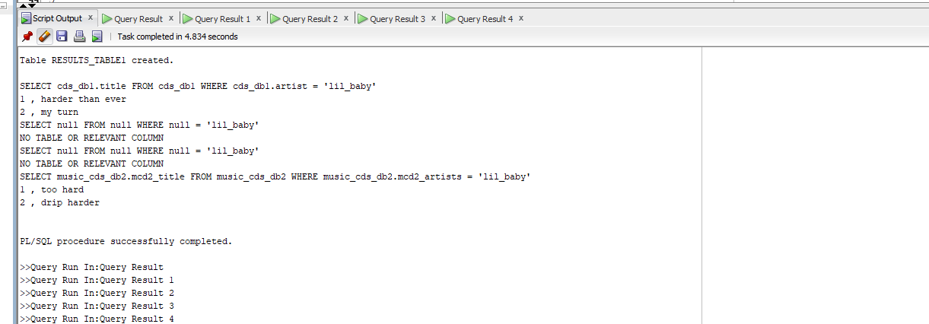

**C)**

Temporary table 1:

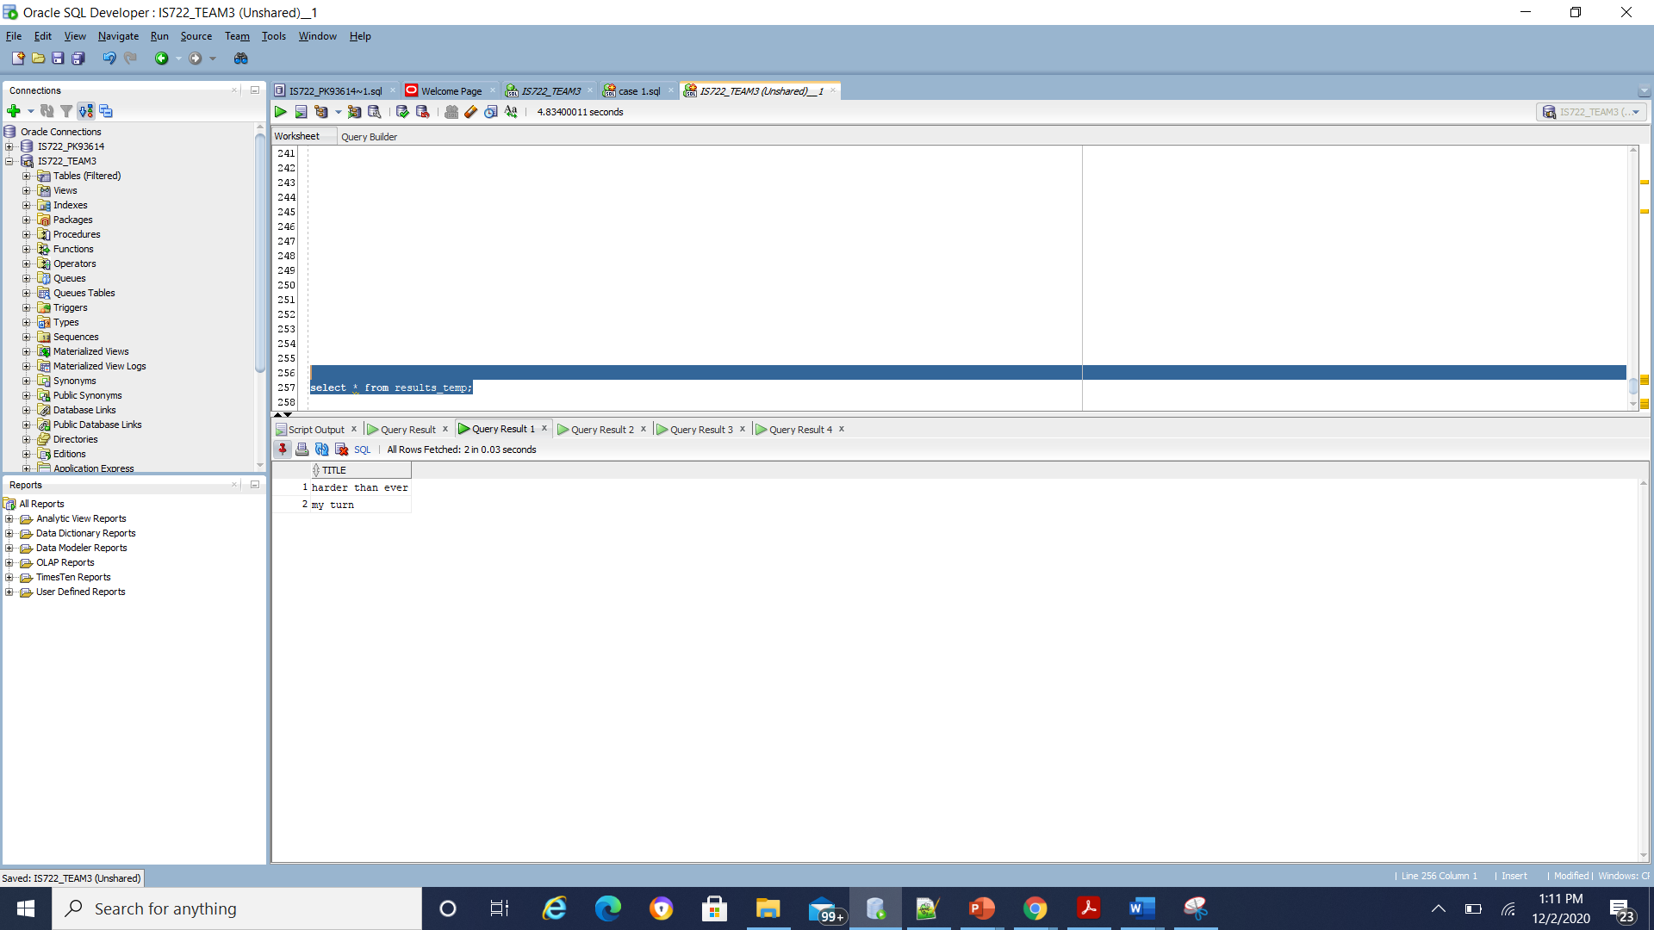

Temporary table 2:

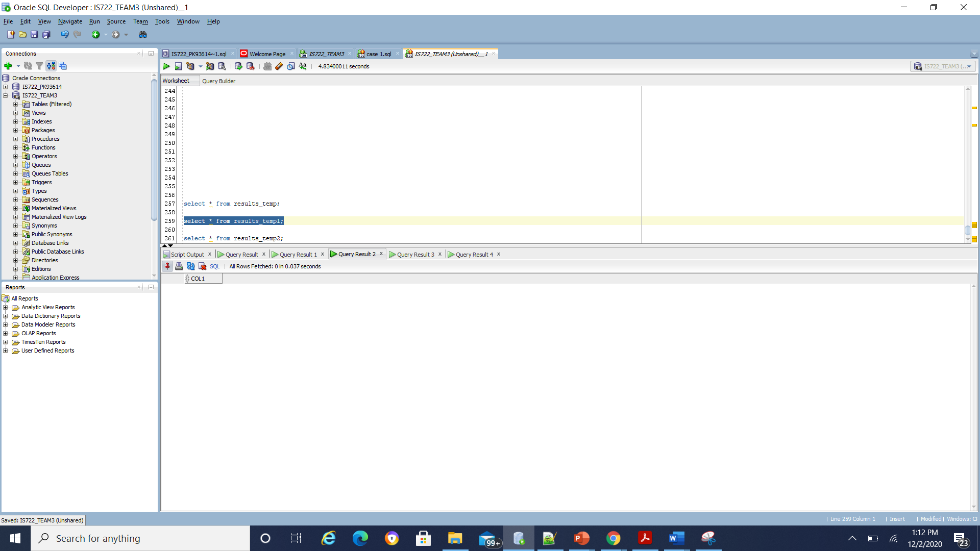

Temporary table 3:

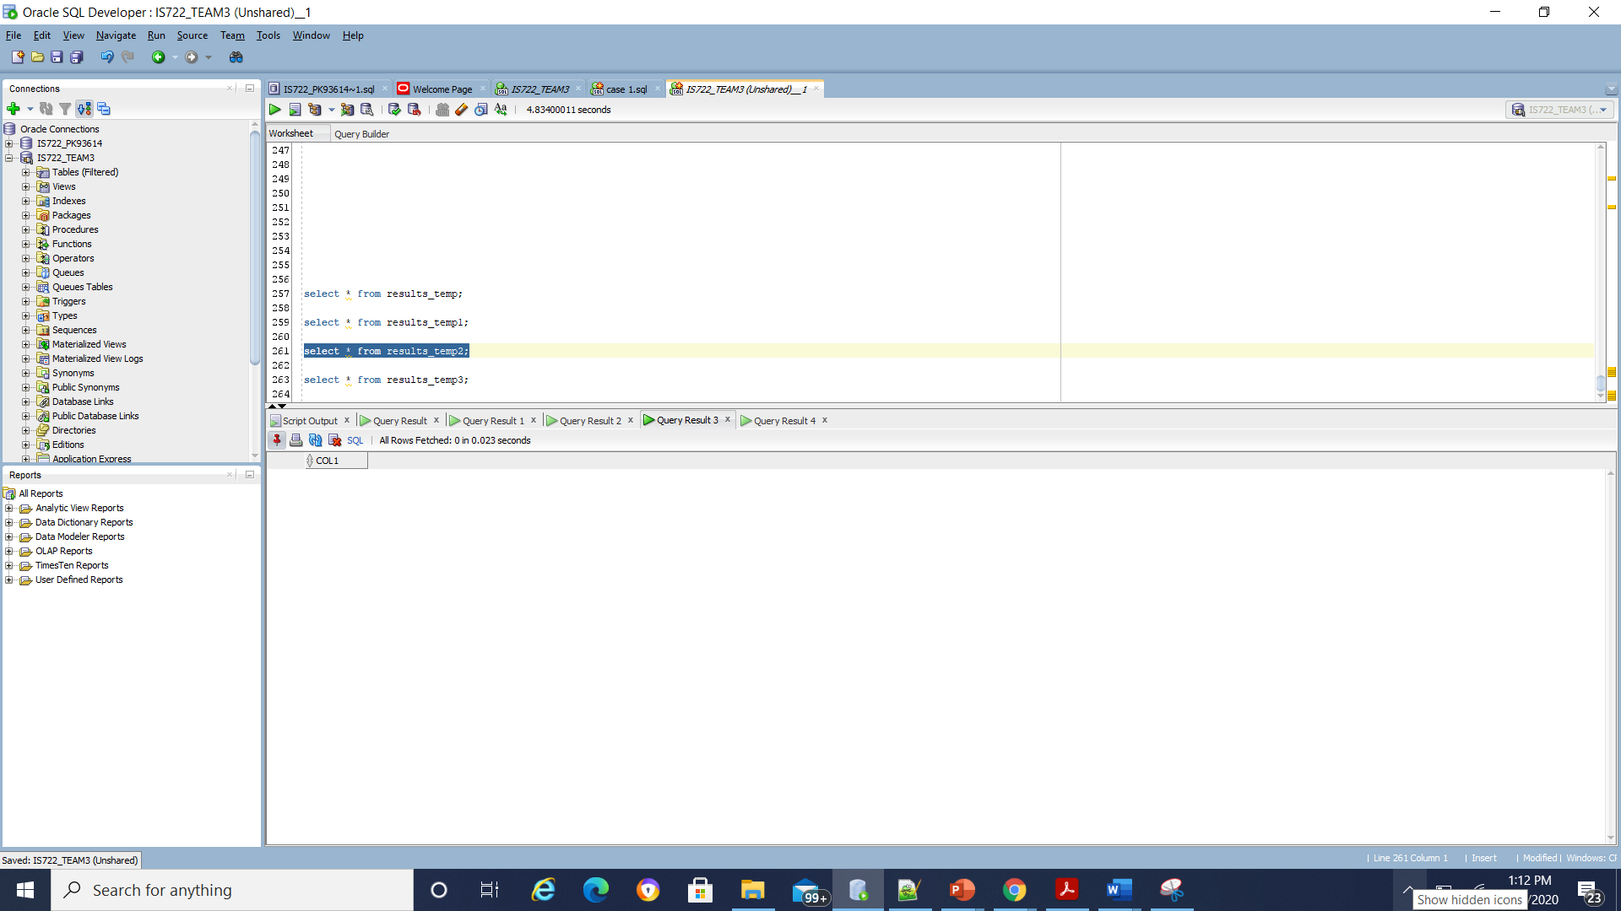

Temporary table 4:

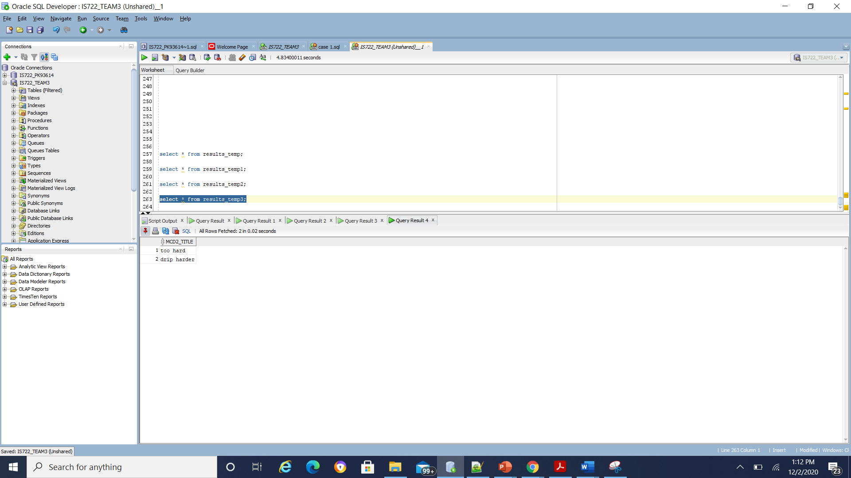

**D)Put together the results of the subqueries by using a UNION operation. Make sure you have union compatible results to demonstrate this case**

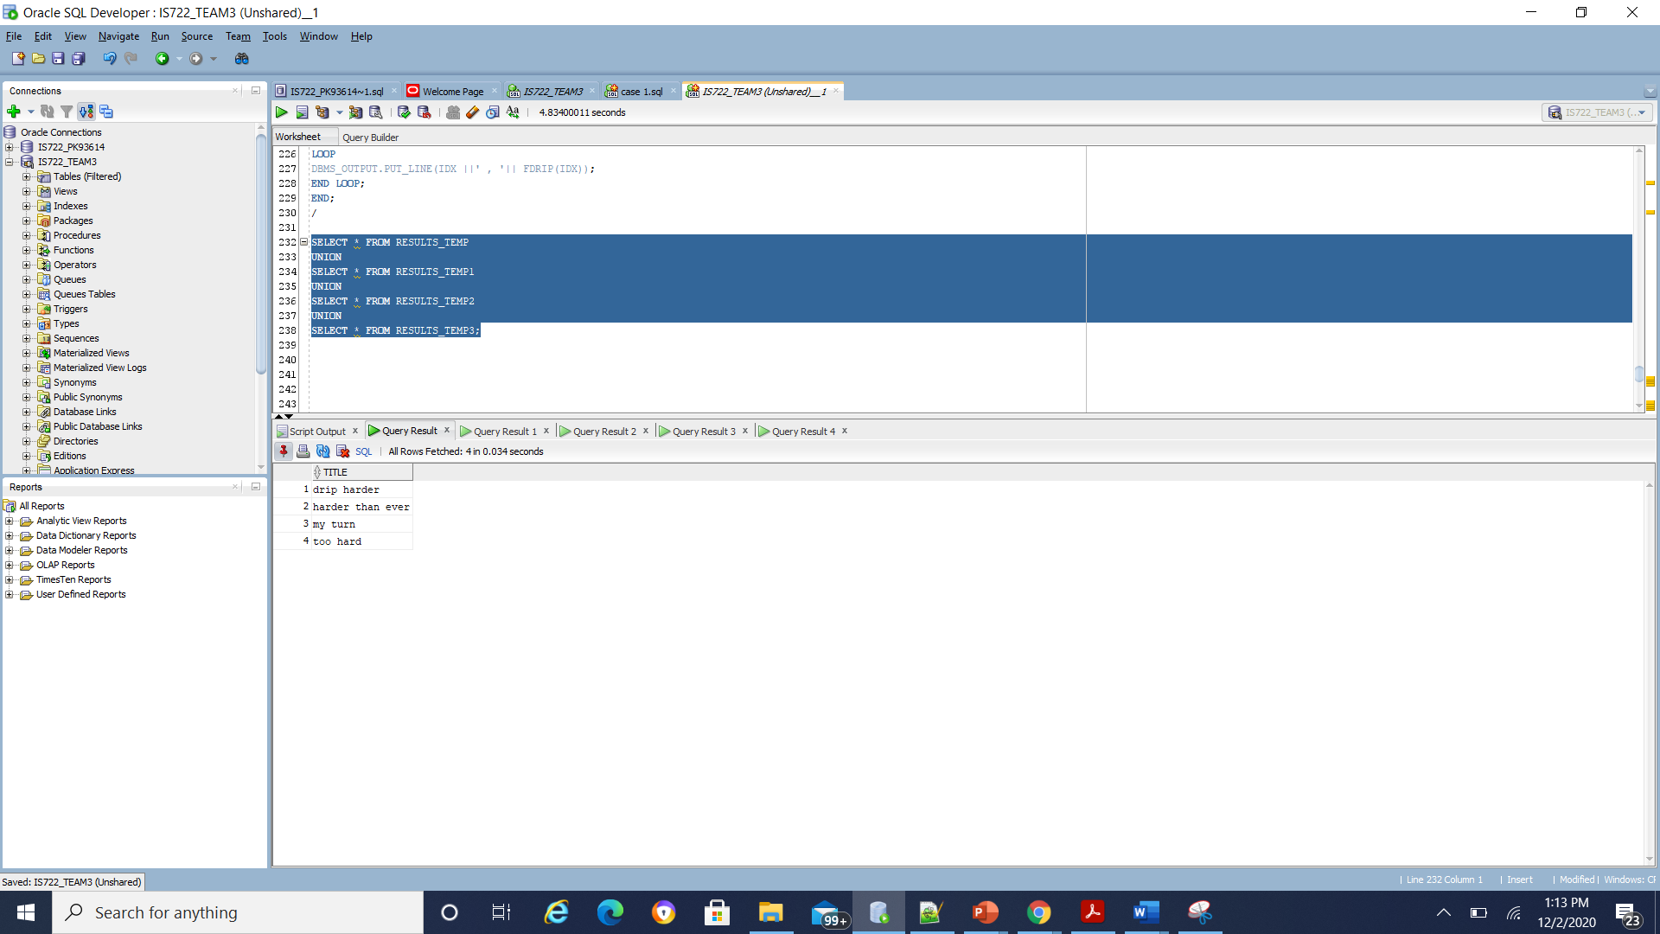

**CASE 3:  Display a few columns from each order in the local databases**

A) GLOBAL QUERY

'SELECT purchase_id, purchase_date FROM purchases_db WHERE purchase_date > ''25-MAY-19'''; ( global query)

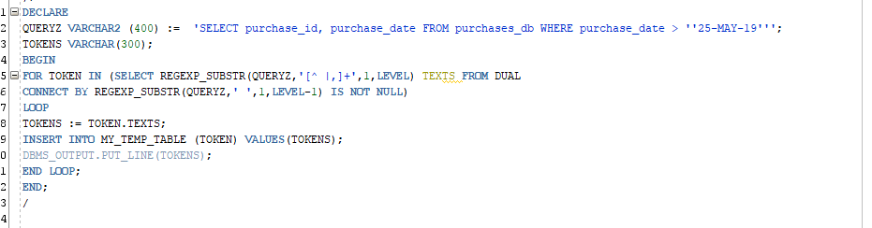

Tokenizer output:

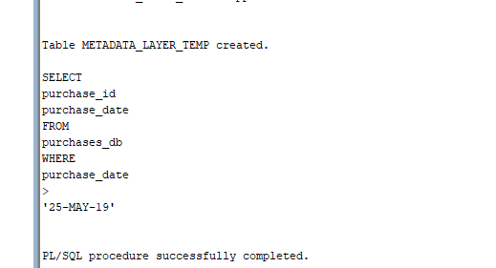

**b) OUTPUT: FROM ALL LOCAL DBS 1,2,3,4 RESPONSES**

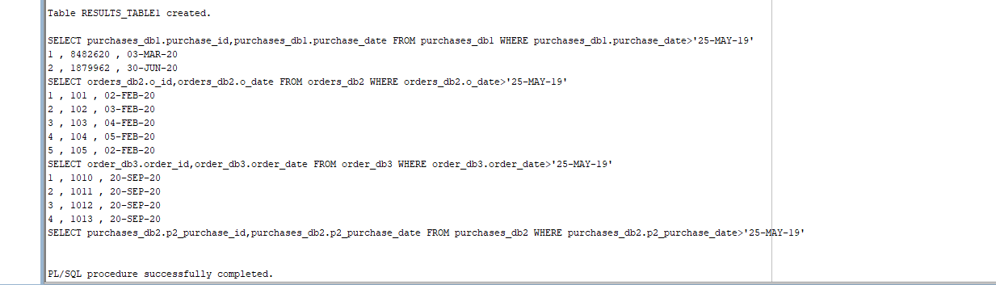

C)

Temporary table1:

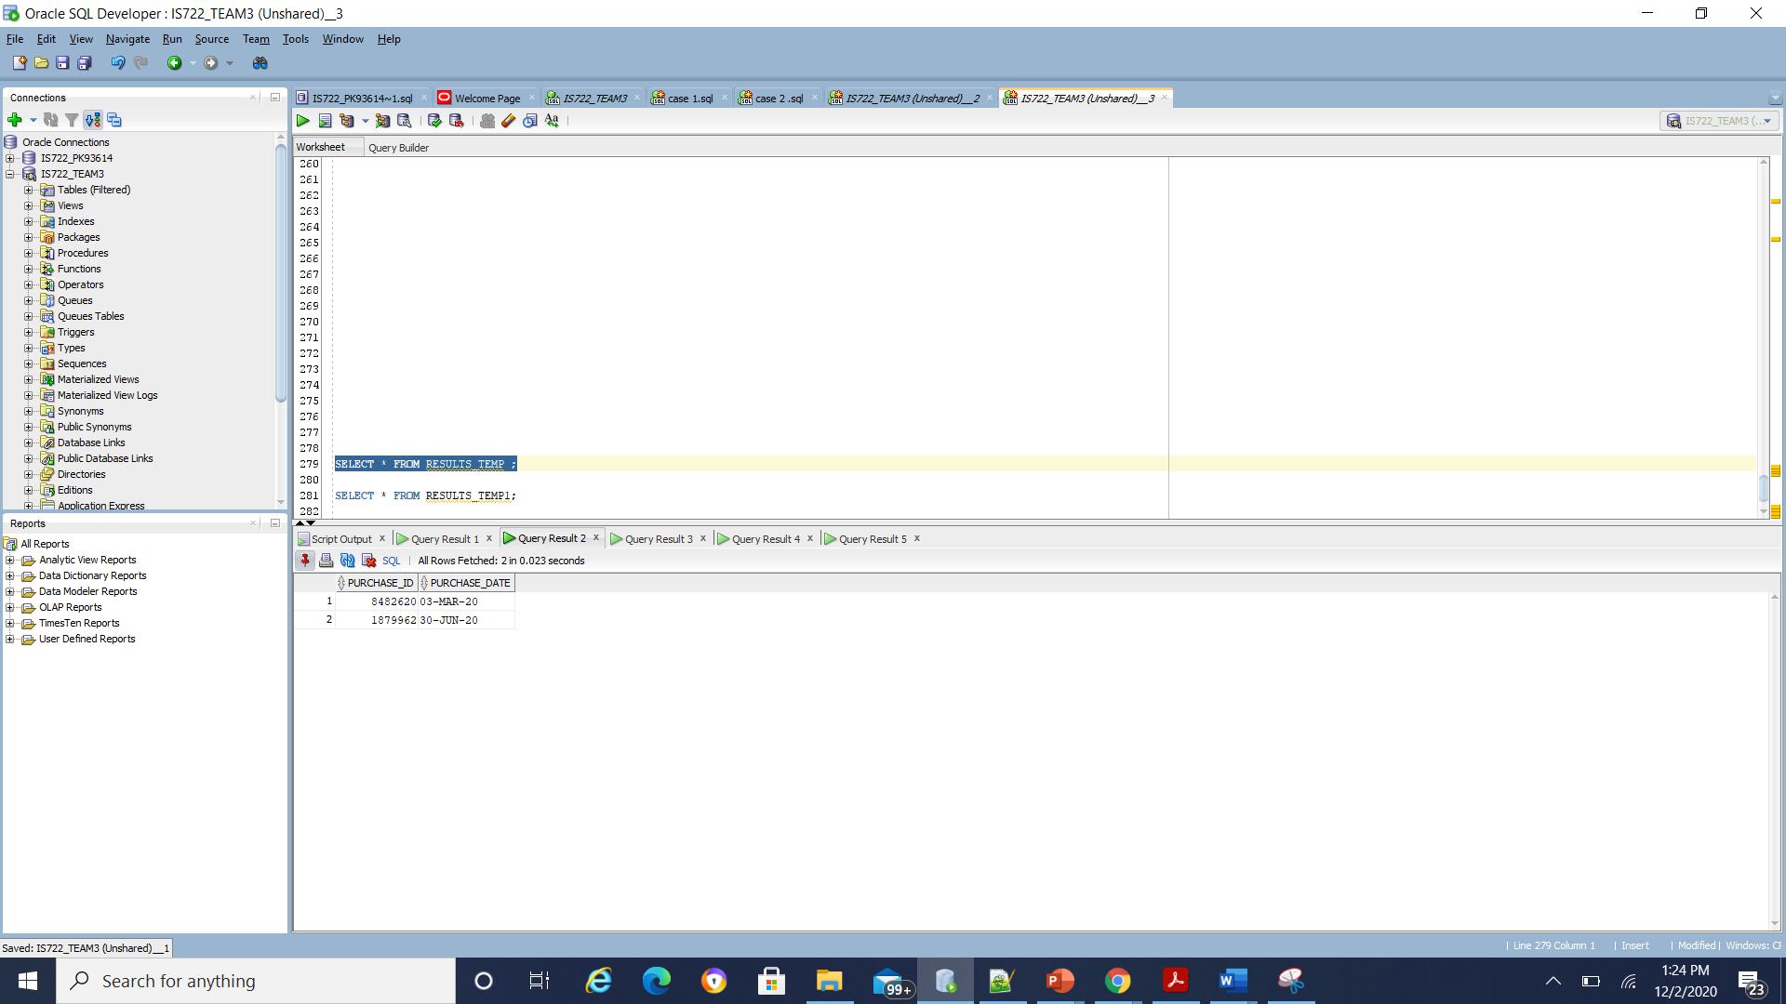

Temporary table 2:

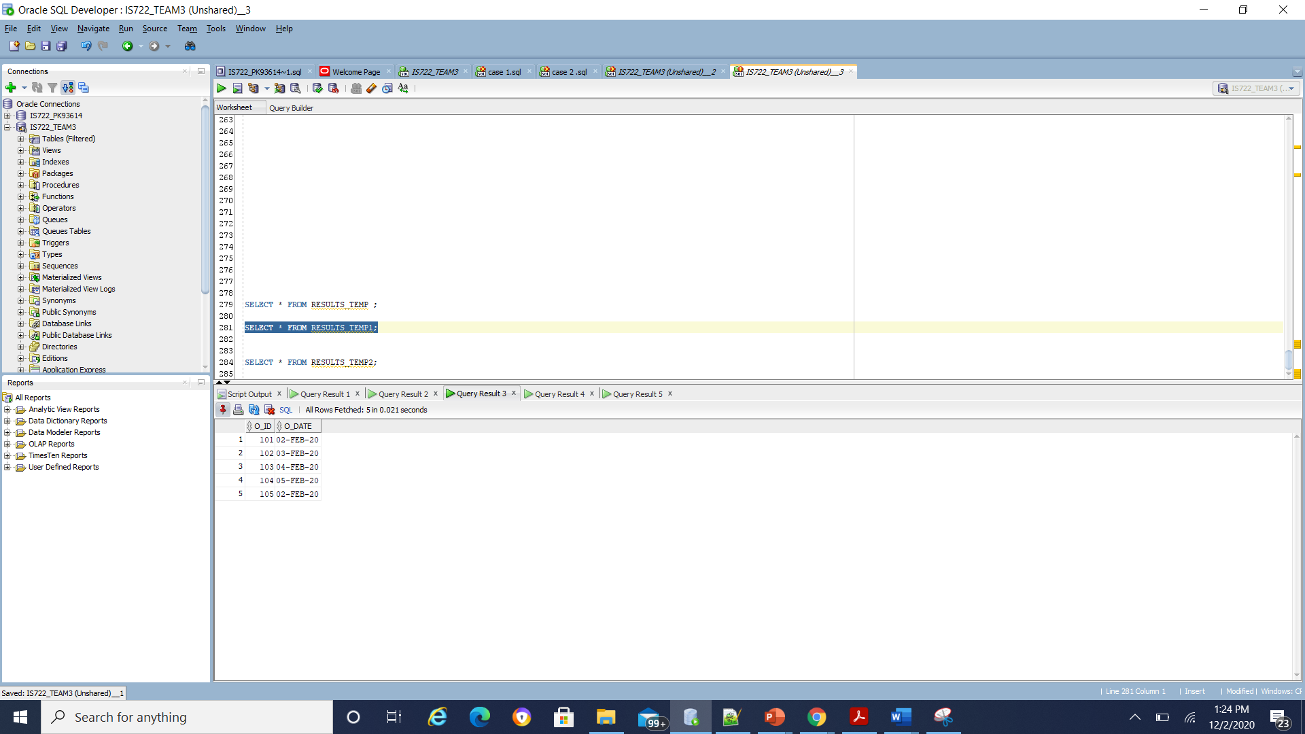

Temporary table 3:

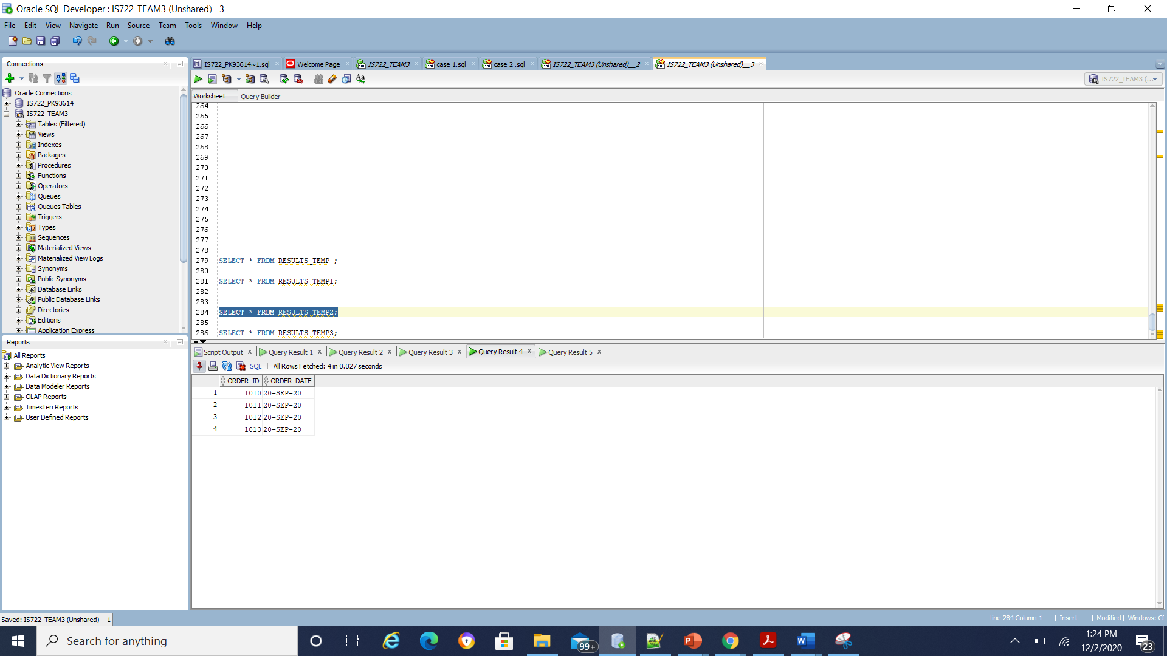

Temporary table 4:

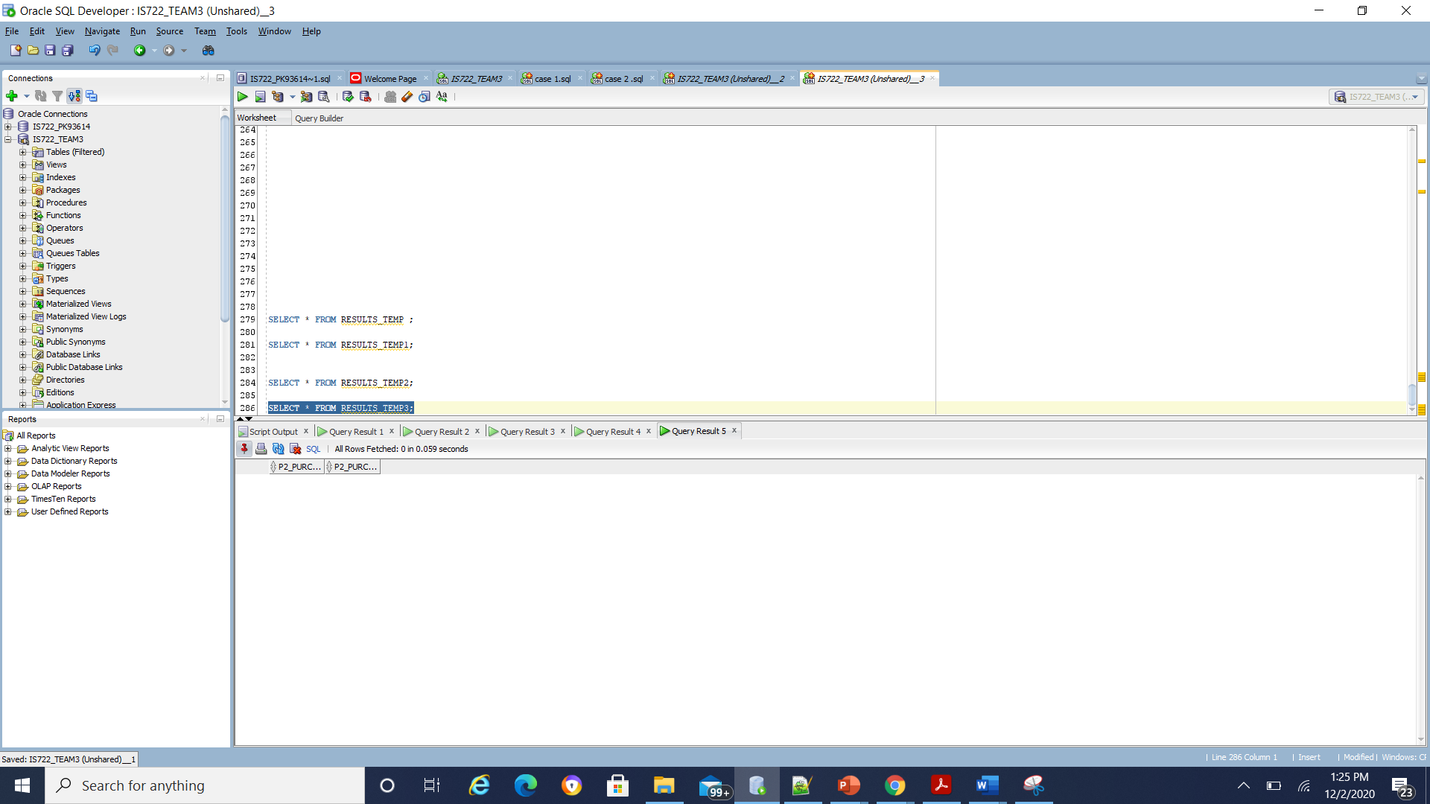

**D)Put together the results of the subqueries by using a UNION operation. Make sure you have union compatible results to demonstrate this case**

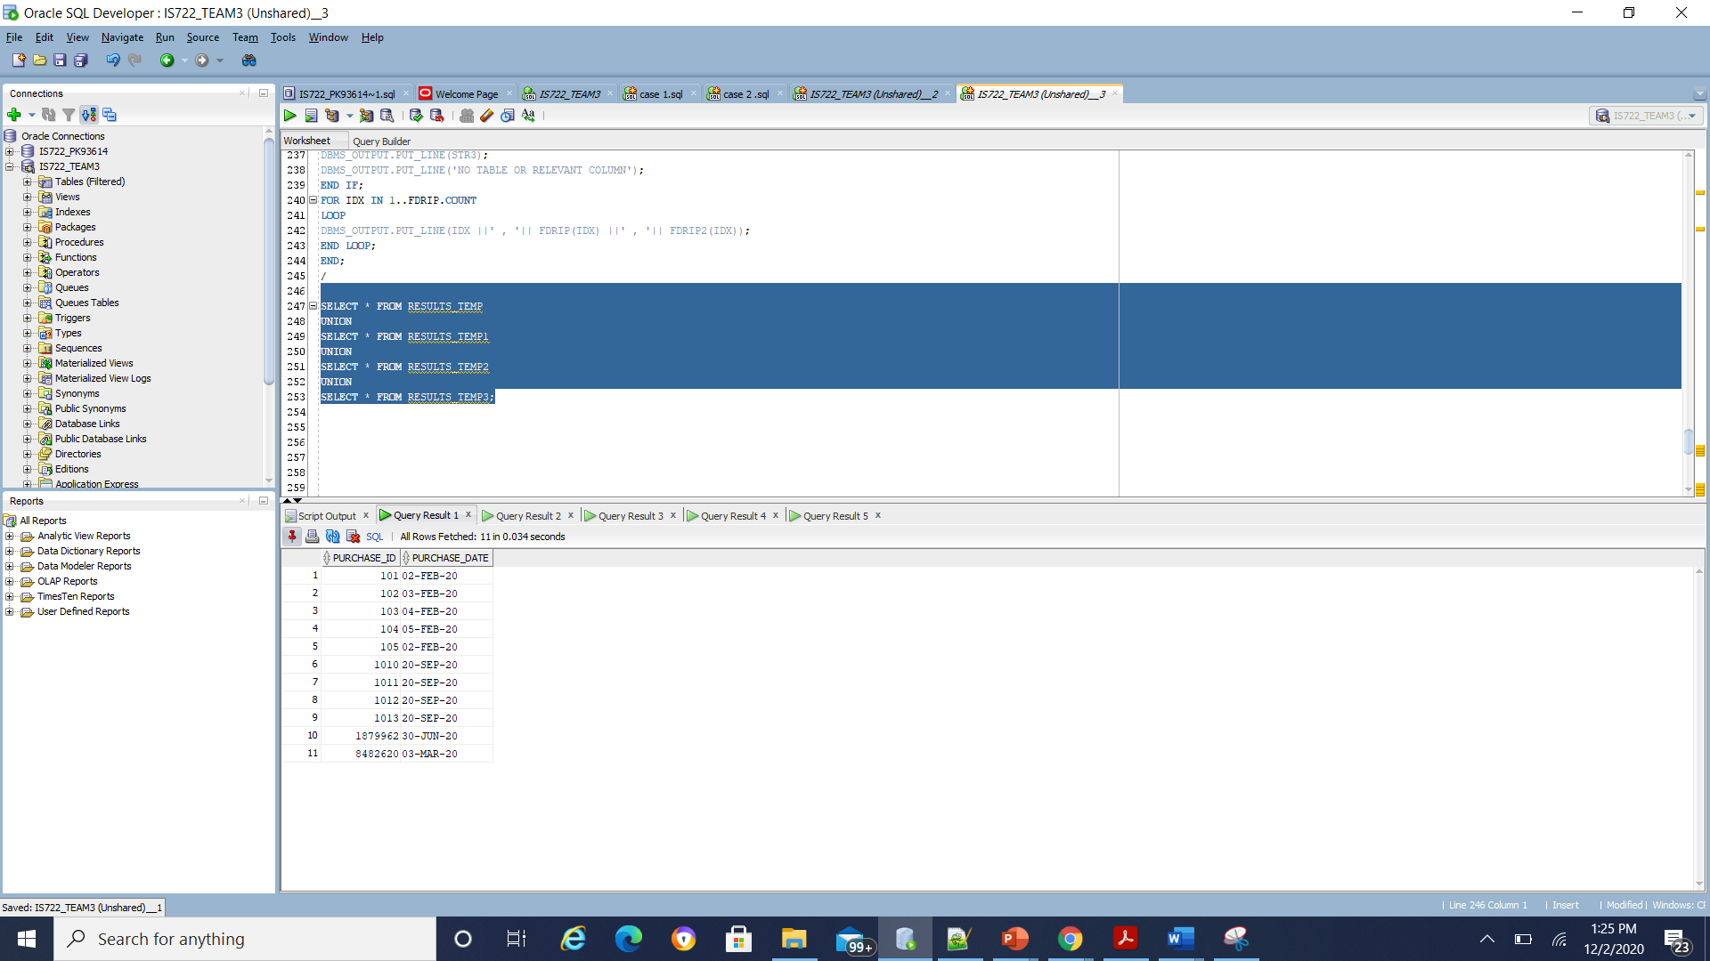

**CASE 4:**Search for each product with at least quantity N (you choose what N is)

A) GLOBAL QUERY

'SELECT product_name FROM product_db WHERE product_quantity > 2'; ( global query)

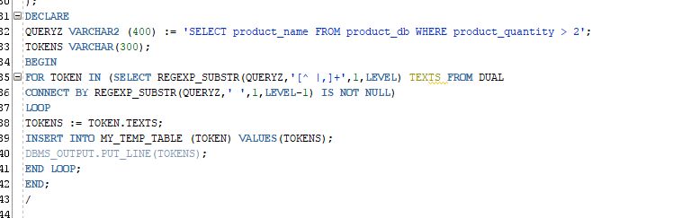

Tokenizer output:

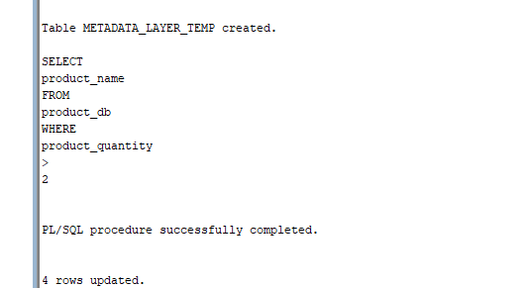

**b) OUTPUT: FROM ALL LOCAL DBS 1,2,3,4 RESPONSES**

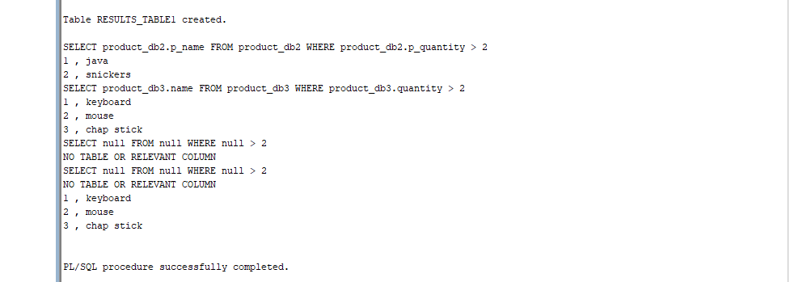

C) PARTIAL RESULTS:

Temporary table 1:

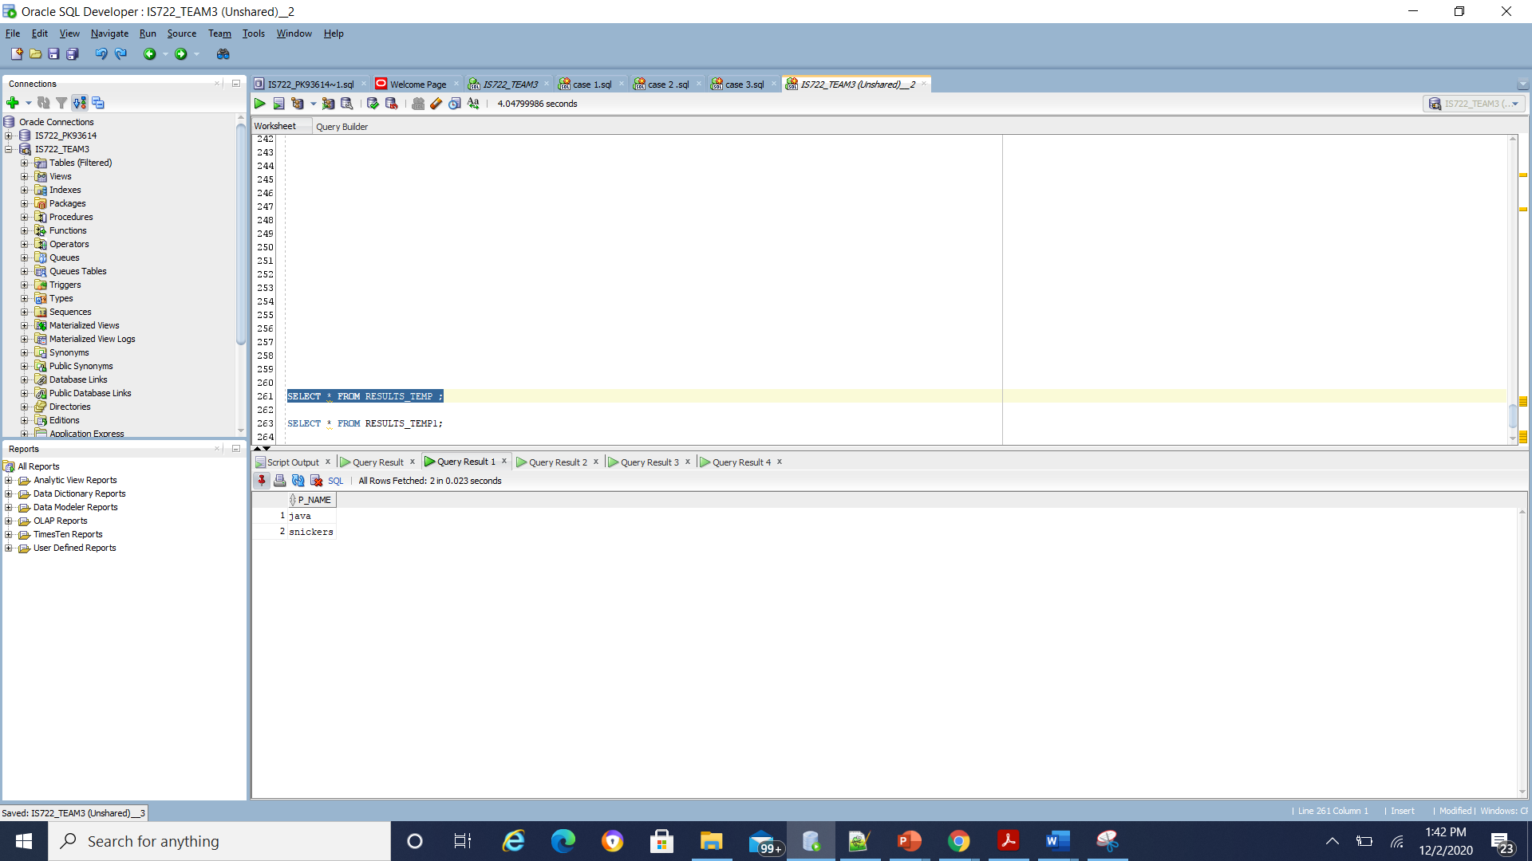

Temporary table 2:

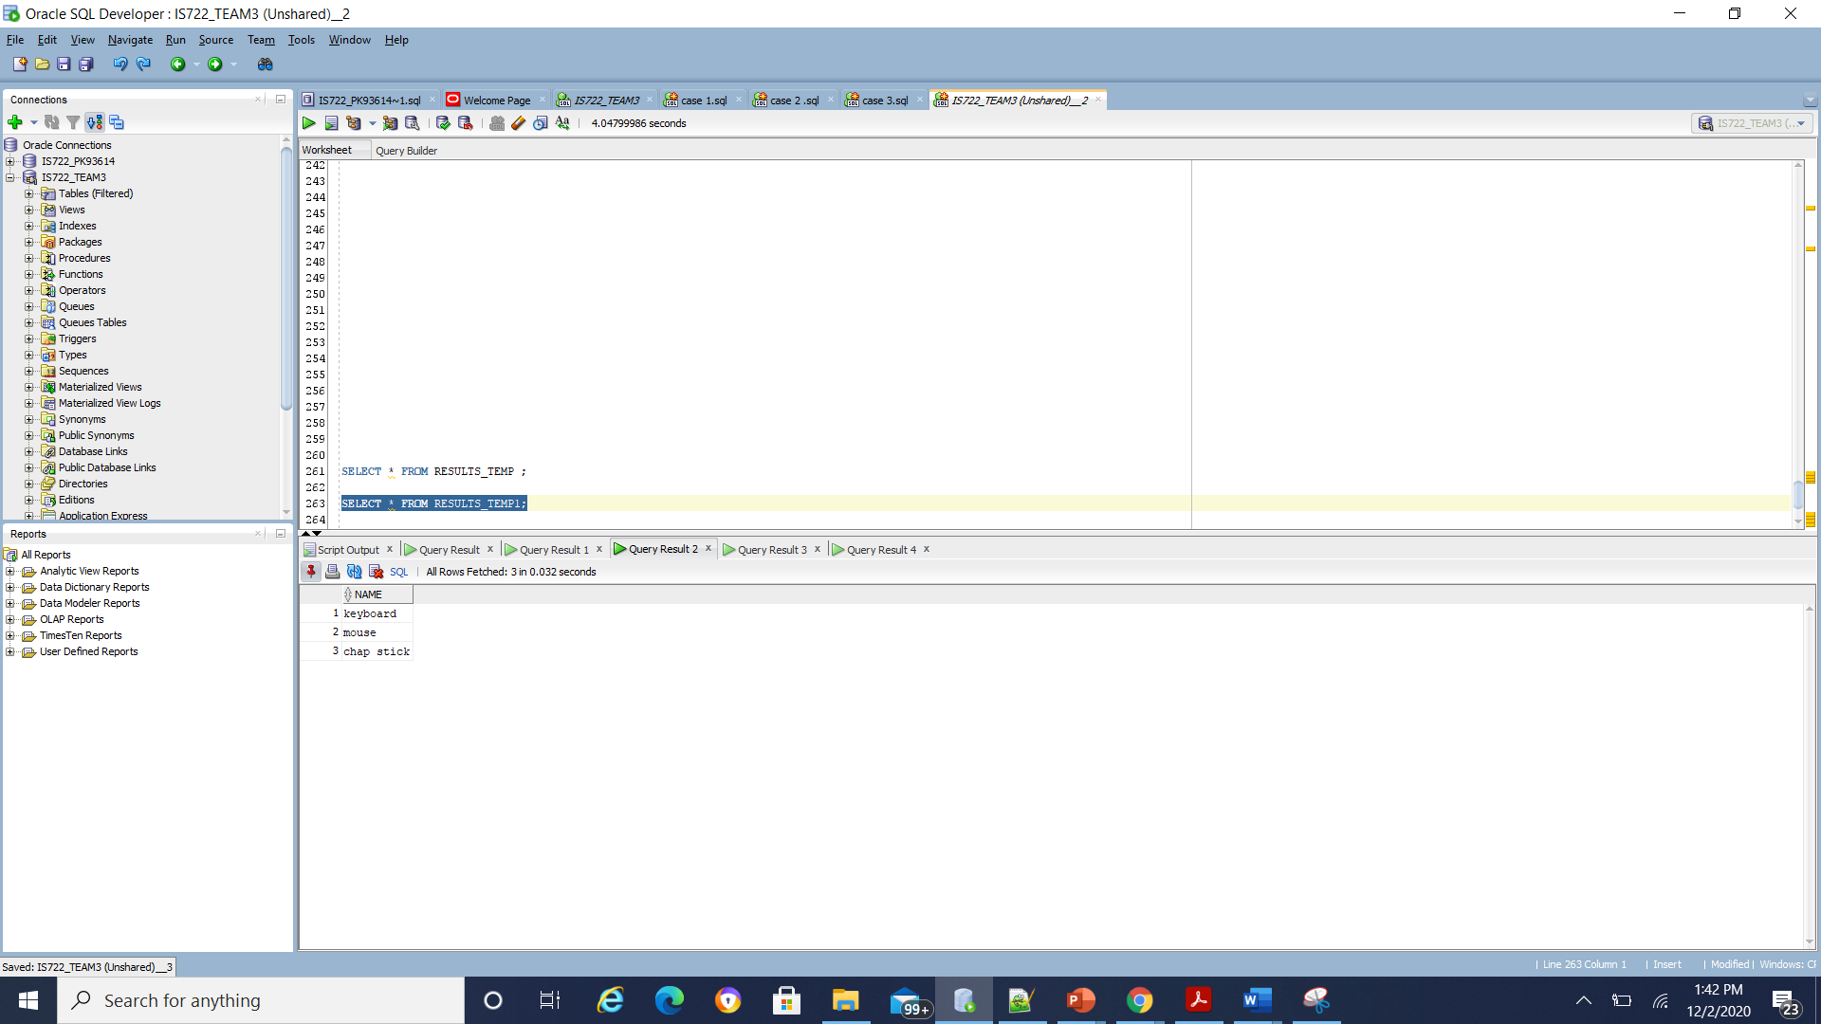

Temporary table 3:

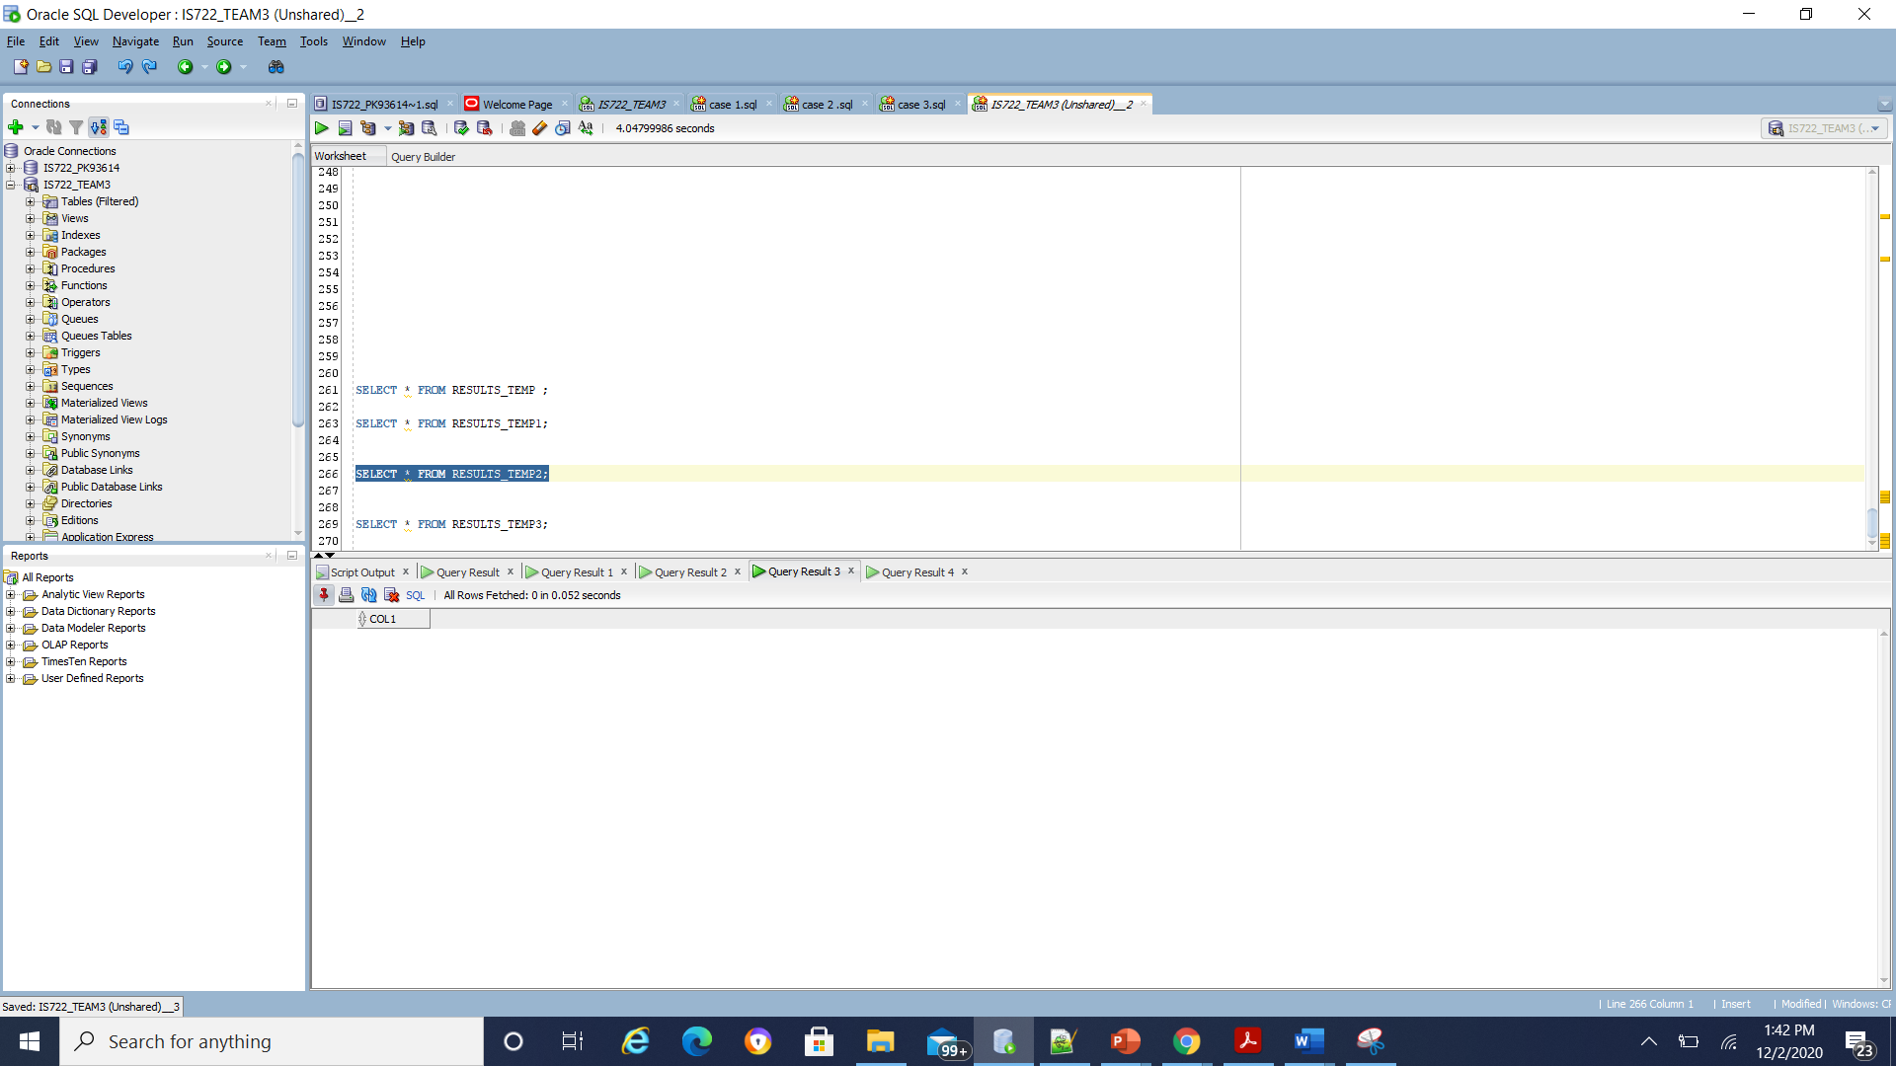

Temporary table 4:

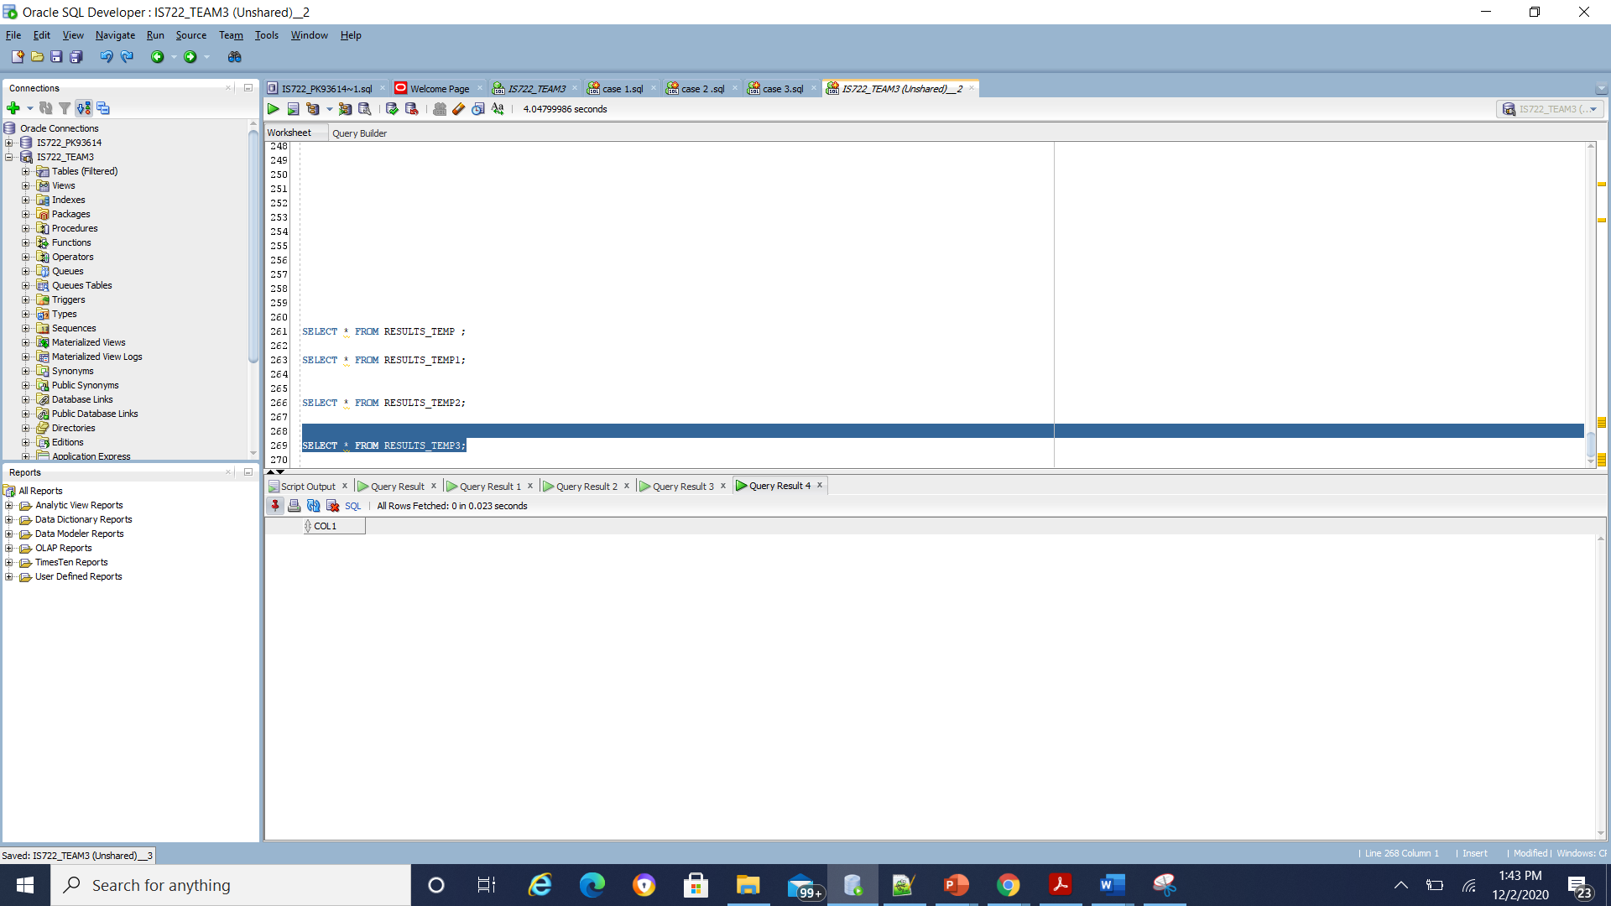

**D) CONSOLIDATED QUERY:**

**Put together the results of the subqueries by using a UNION operation. Make sure you have union compatible results to demonstrate this case**

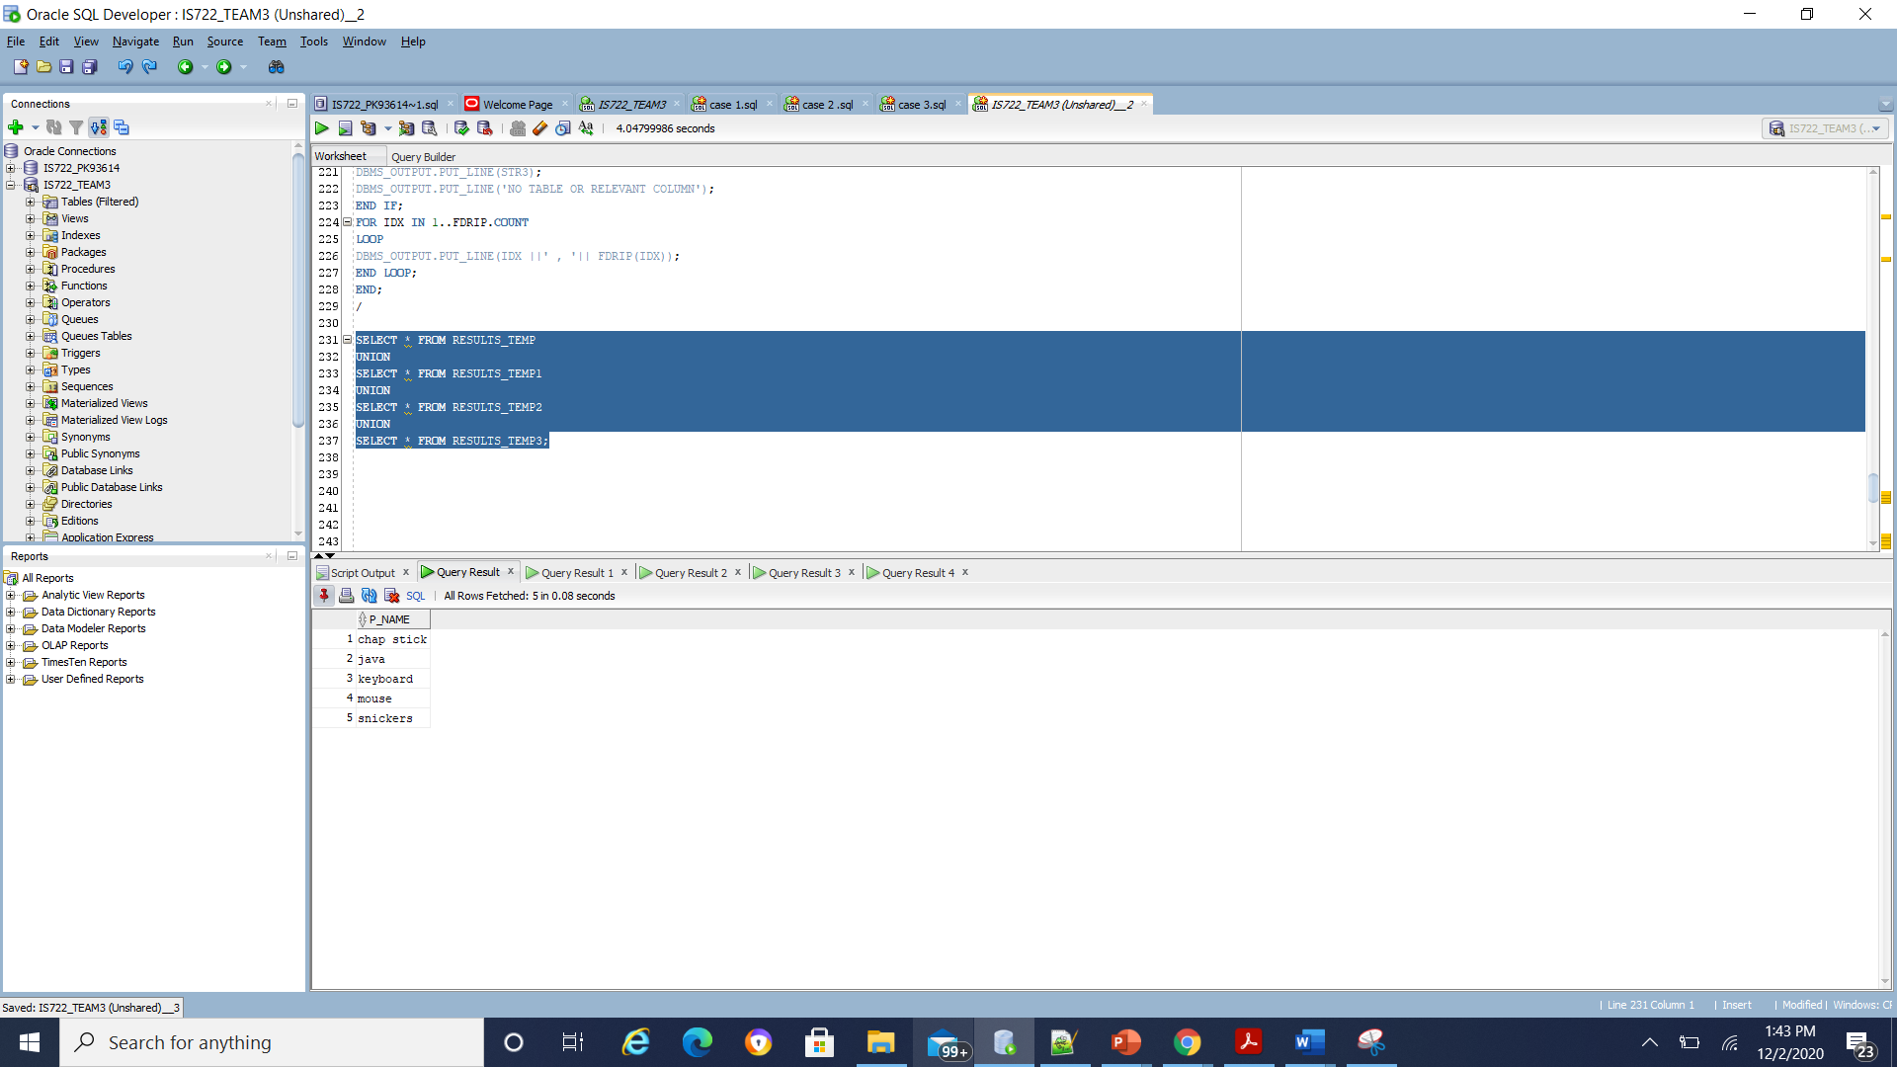

**CASE 5:**Display all orders of a particular customer

A) GLOBAL QUERY

 'SELECT purchase_id FROM purchases_db WHERE purchase_customer_id = ''47931'''; ( global query)

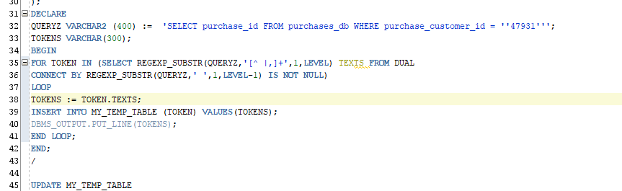

Tokenizer output:

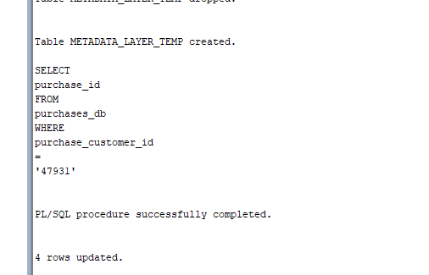

**b) SUBQUERIES OUTPUT: FROM ALL LOCAL DBS 1,2,3,4 RESPONSES**

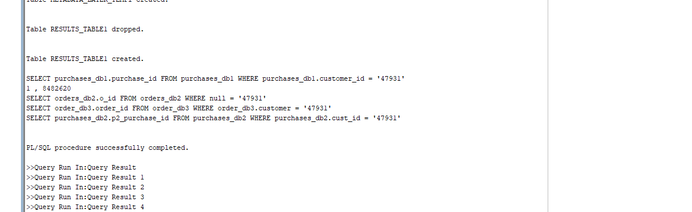

**C) PARTIAL RESULTS:**

Temporary table1:

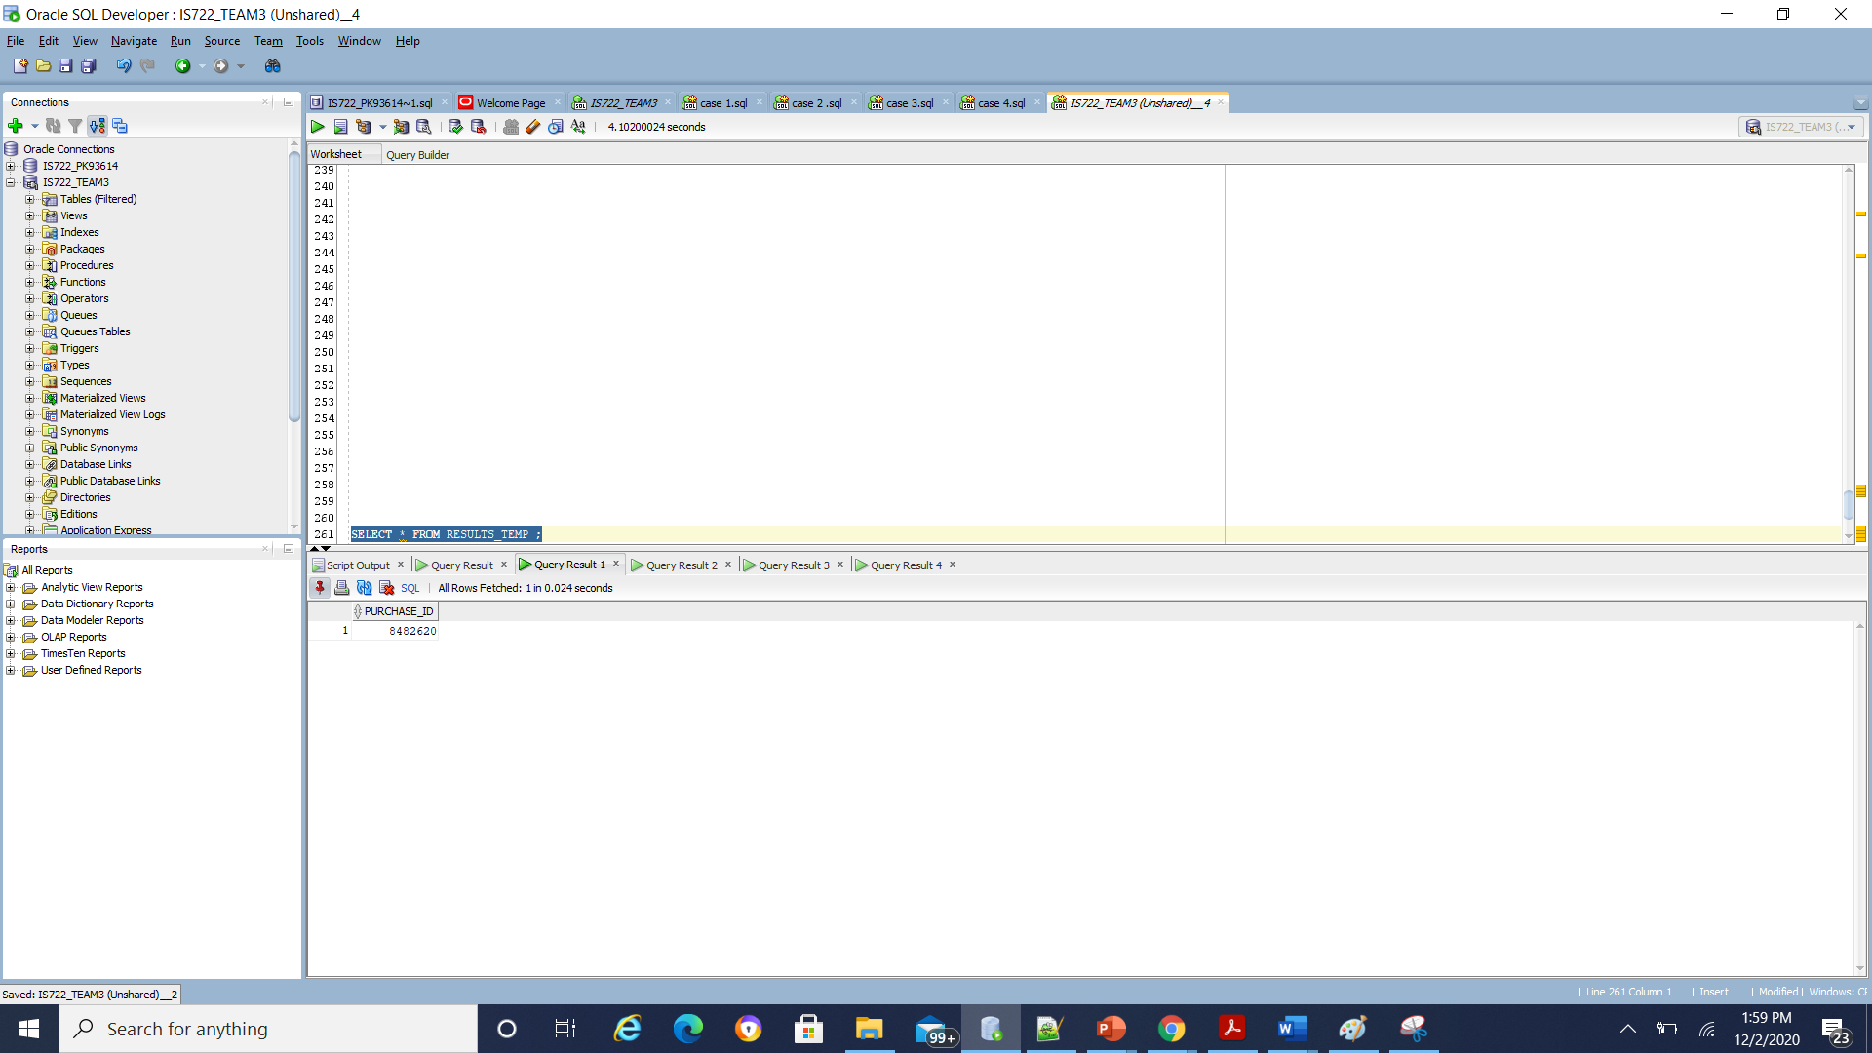

Temporary table 2:

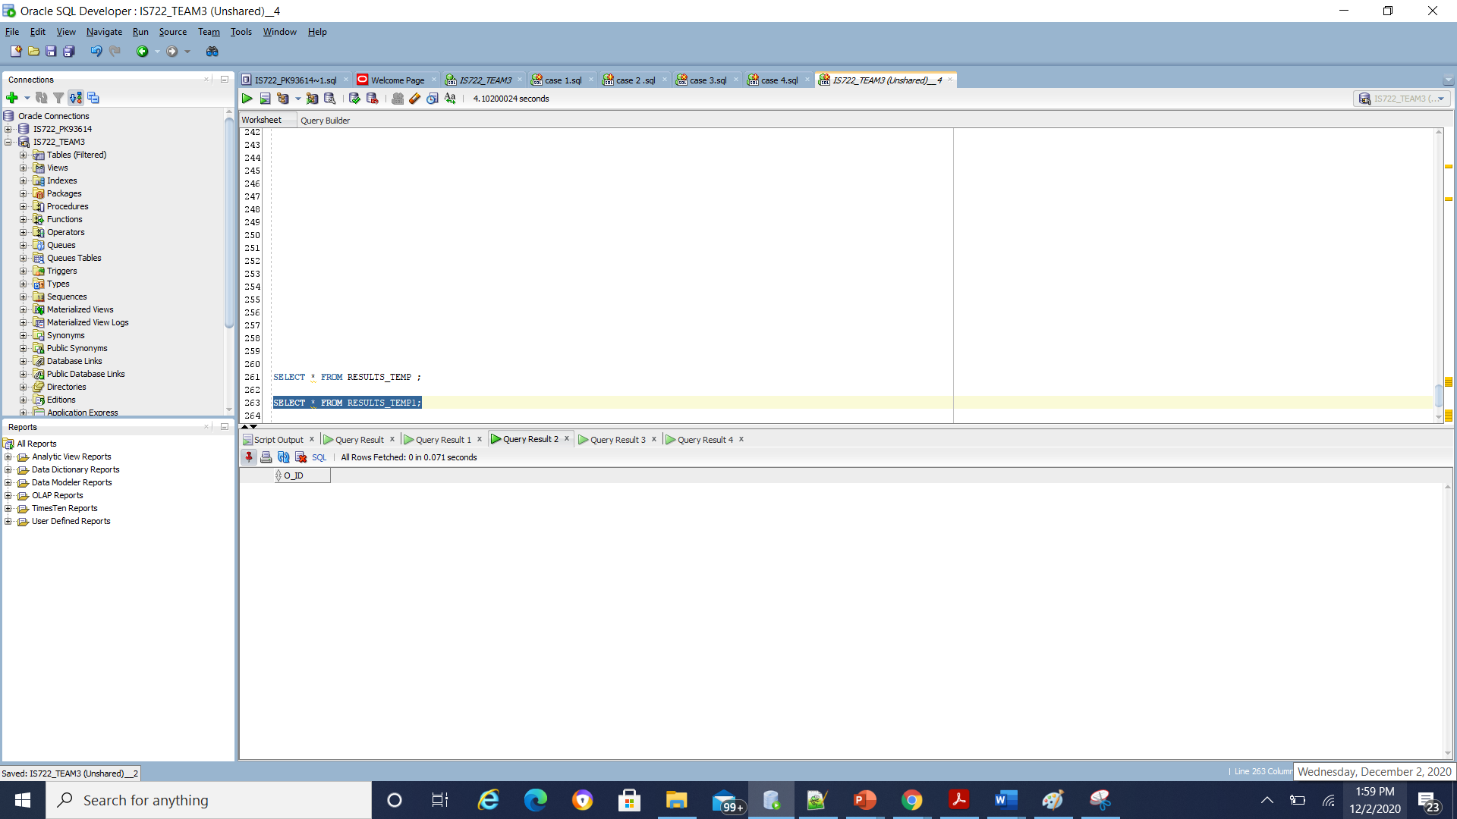

Temporary table 3:

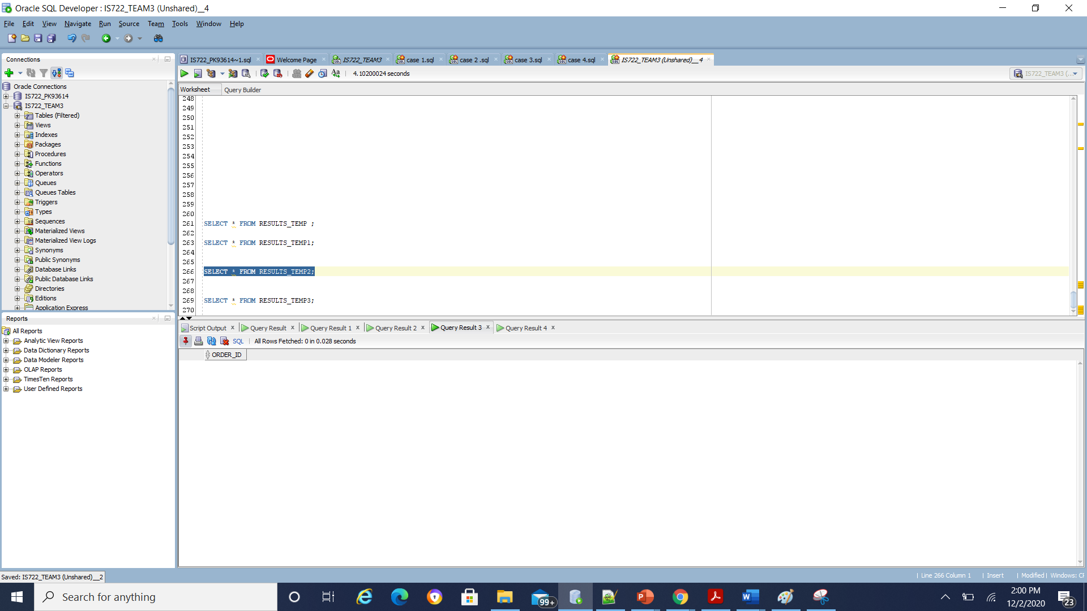

Temporary table 4:

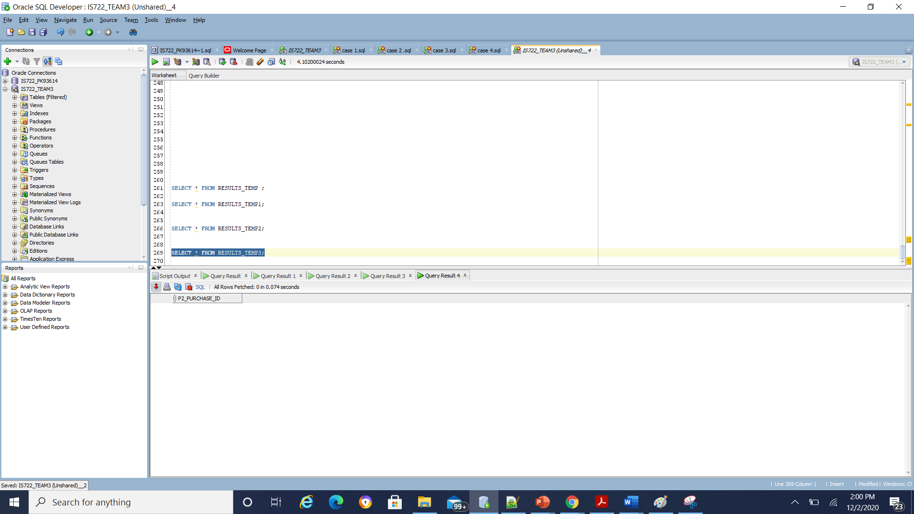

**D) CONSOLIDATED QUERY: OVERALL RESULTS:**

**Put together the results of the subqueries by using a UNION operation. Make sure you have union compatible results to demonstrate this case**

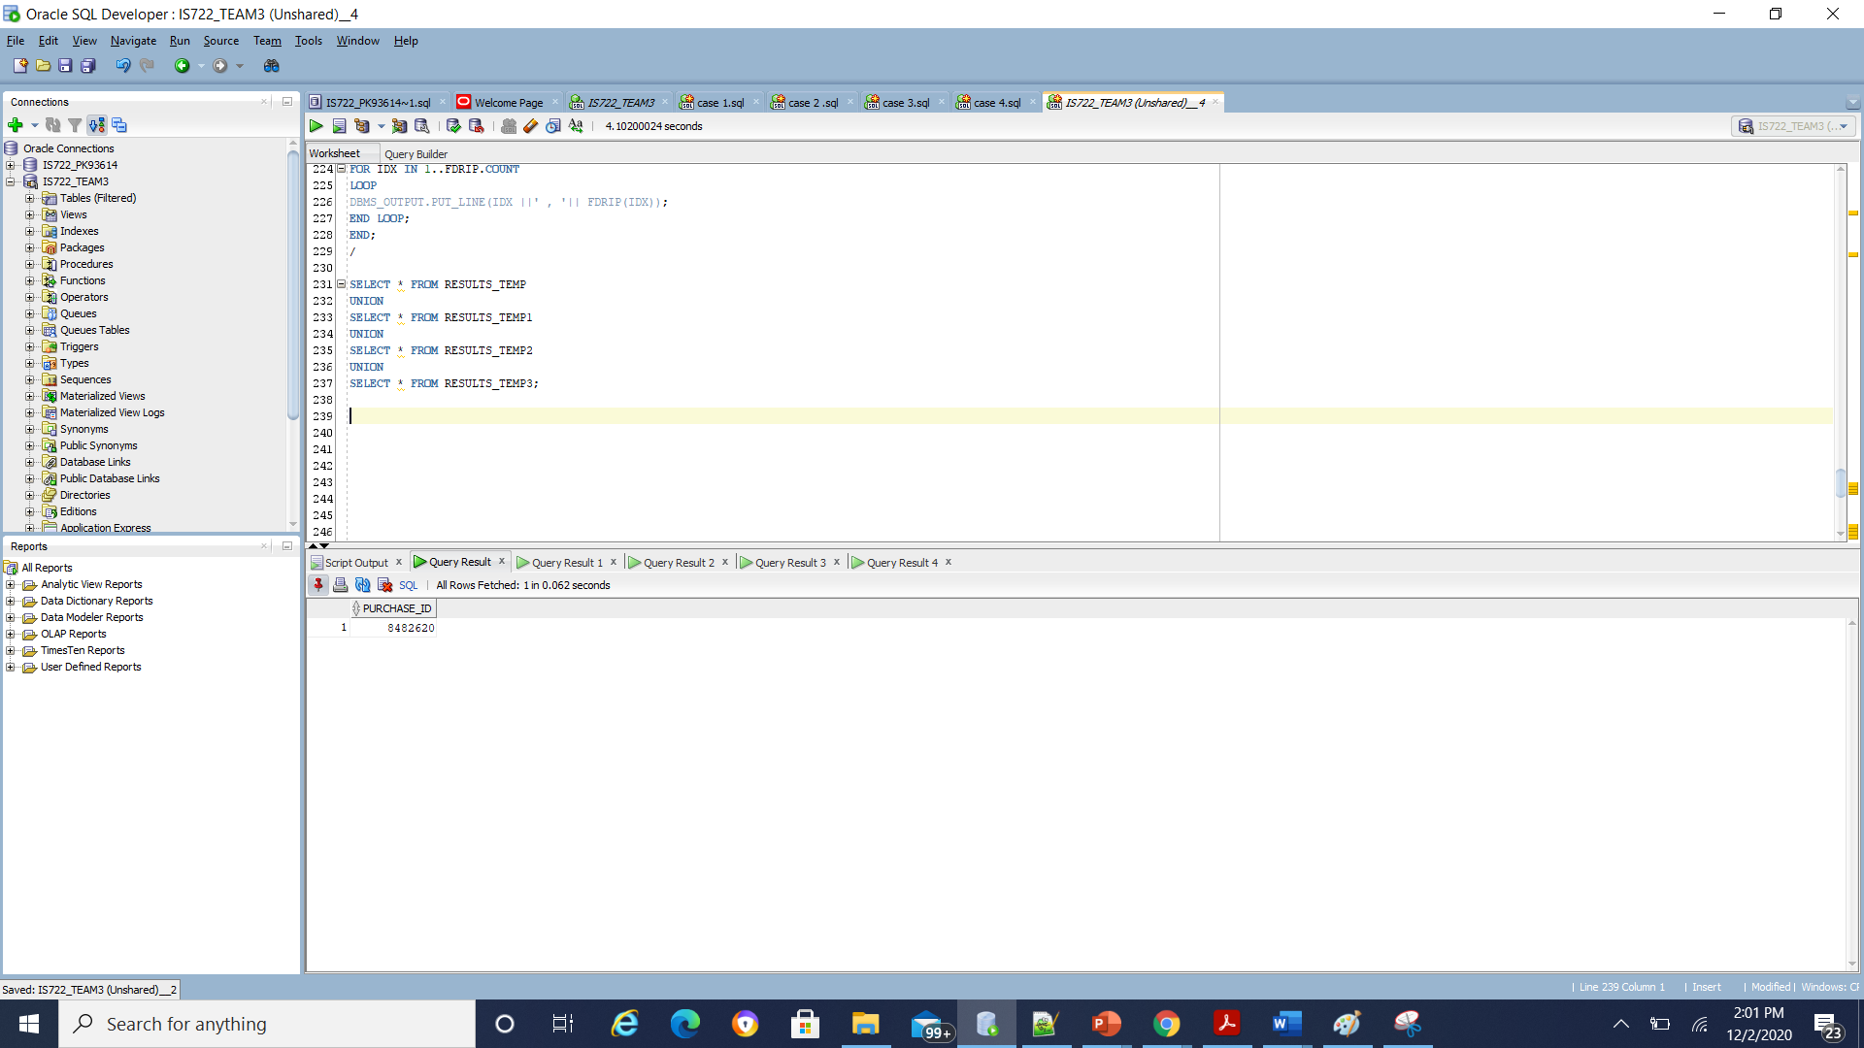

**CASE 6:**Display all orders of a particular customer

A) GLOBAL QUERY

'SELECT customer_first_name, street_address FROM customers_db WHERE city = ''Columbia'’'; ( global query)

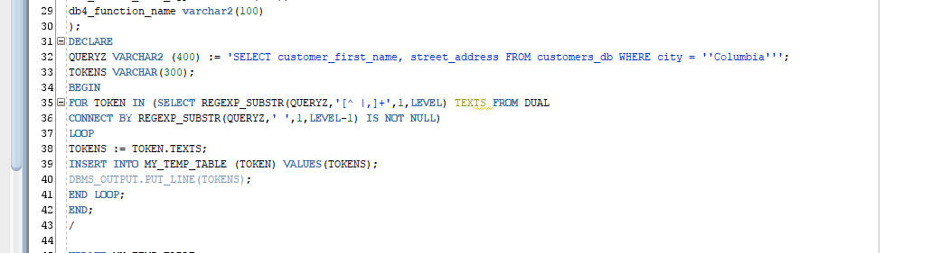

Tokenizer output:

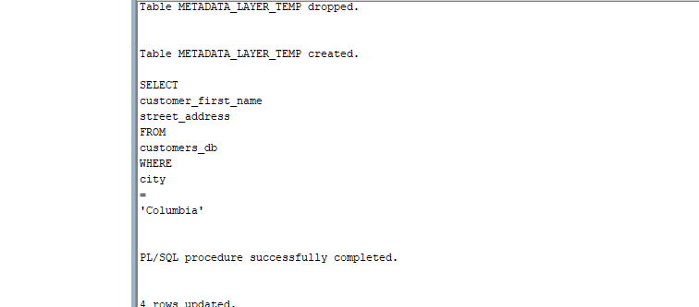

B) **SUBQUERIES OUTPUT: FROM ALL LOCAL DBS 1,2,3,4 RESPONSES**

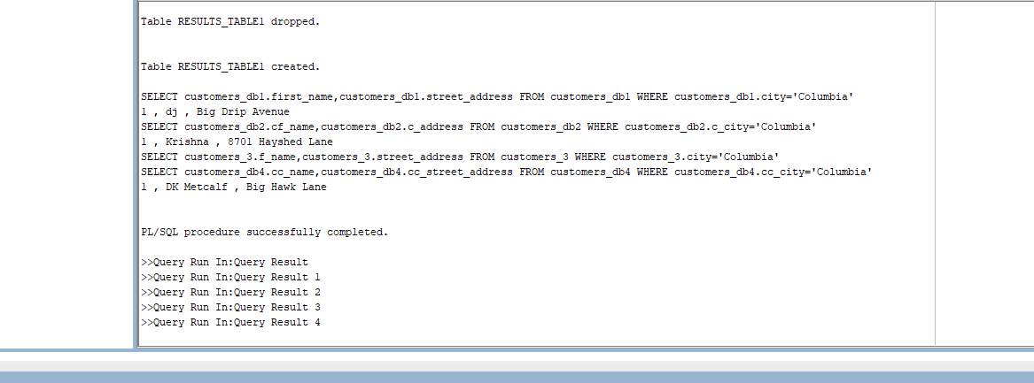

C) PARTIAL RESULTS:

Temporary table 1:

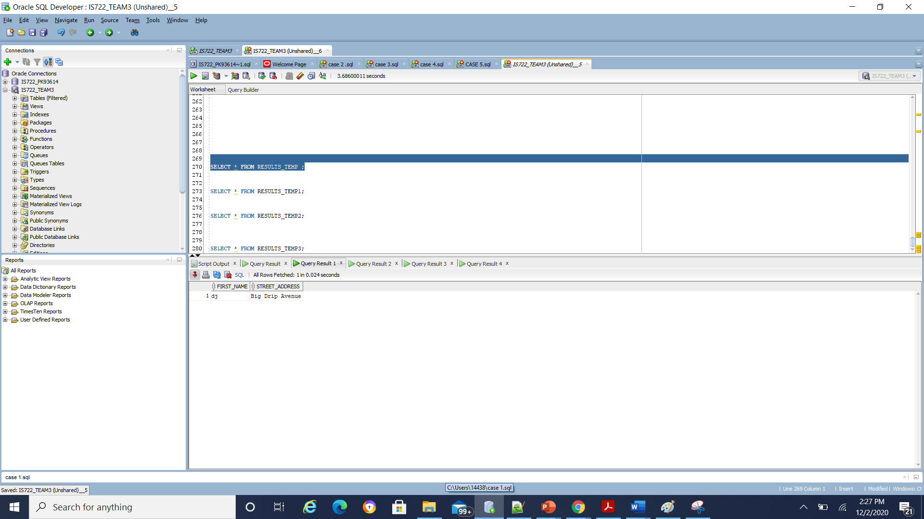

Temporary table 2:

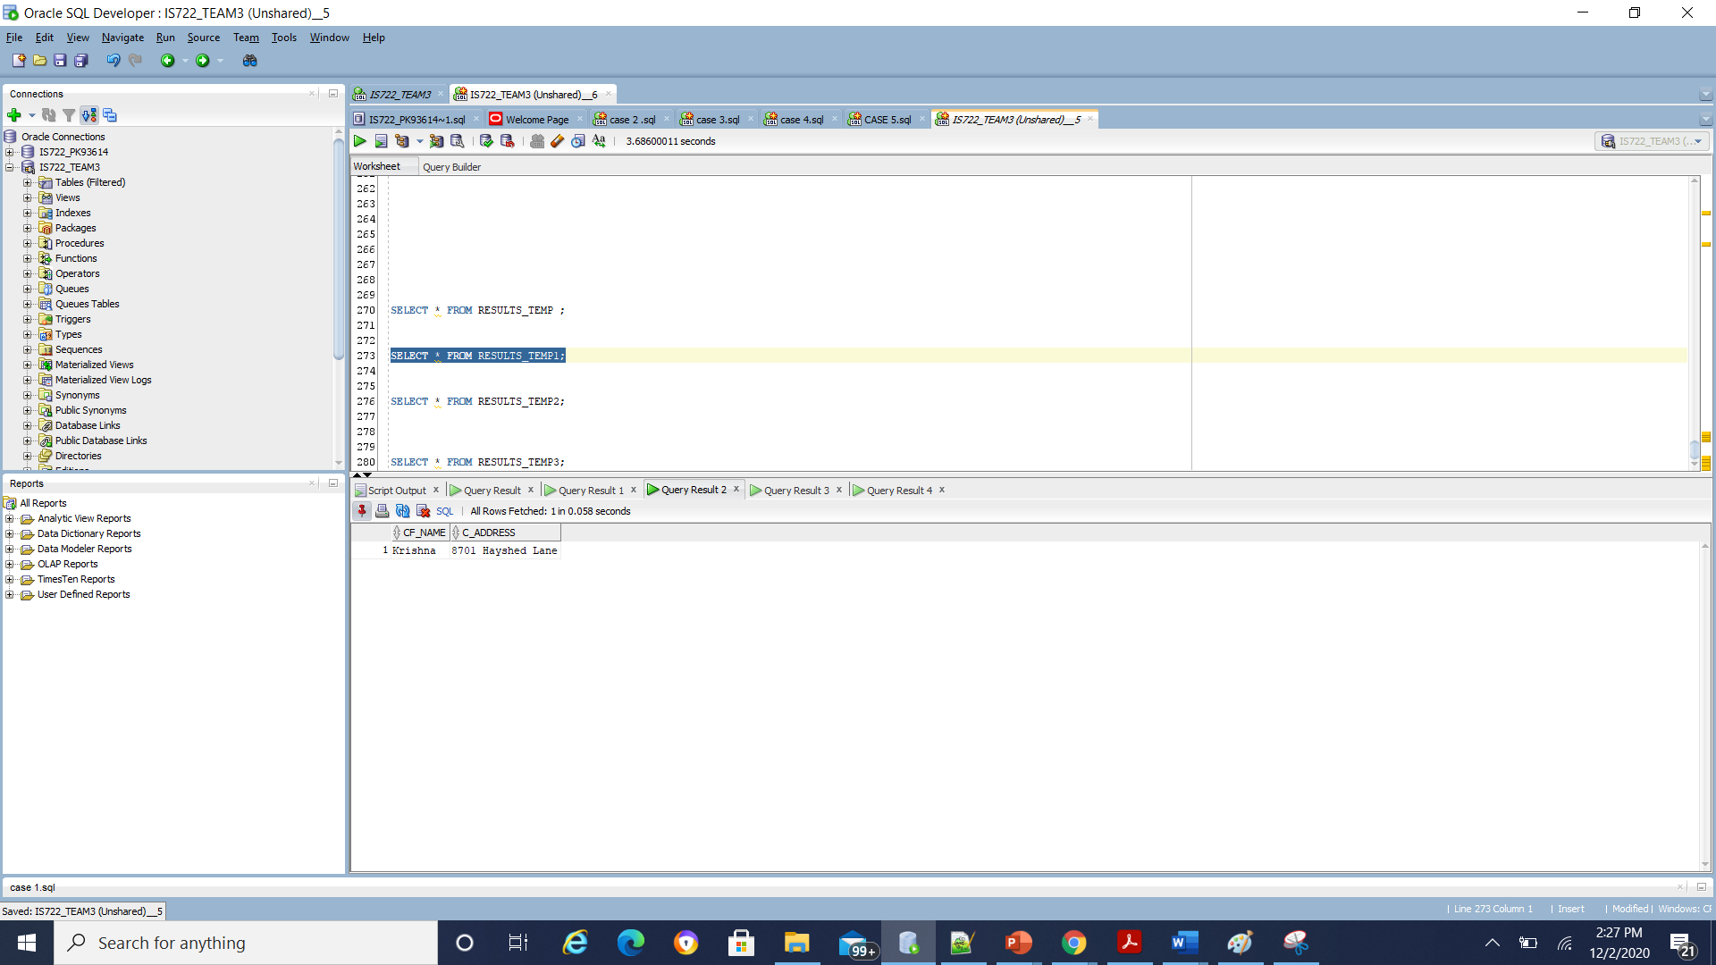

Temporary table 3:

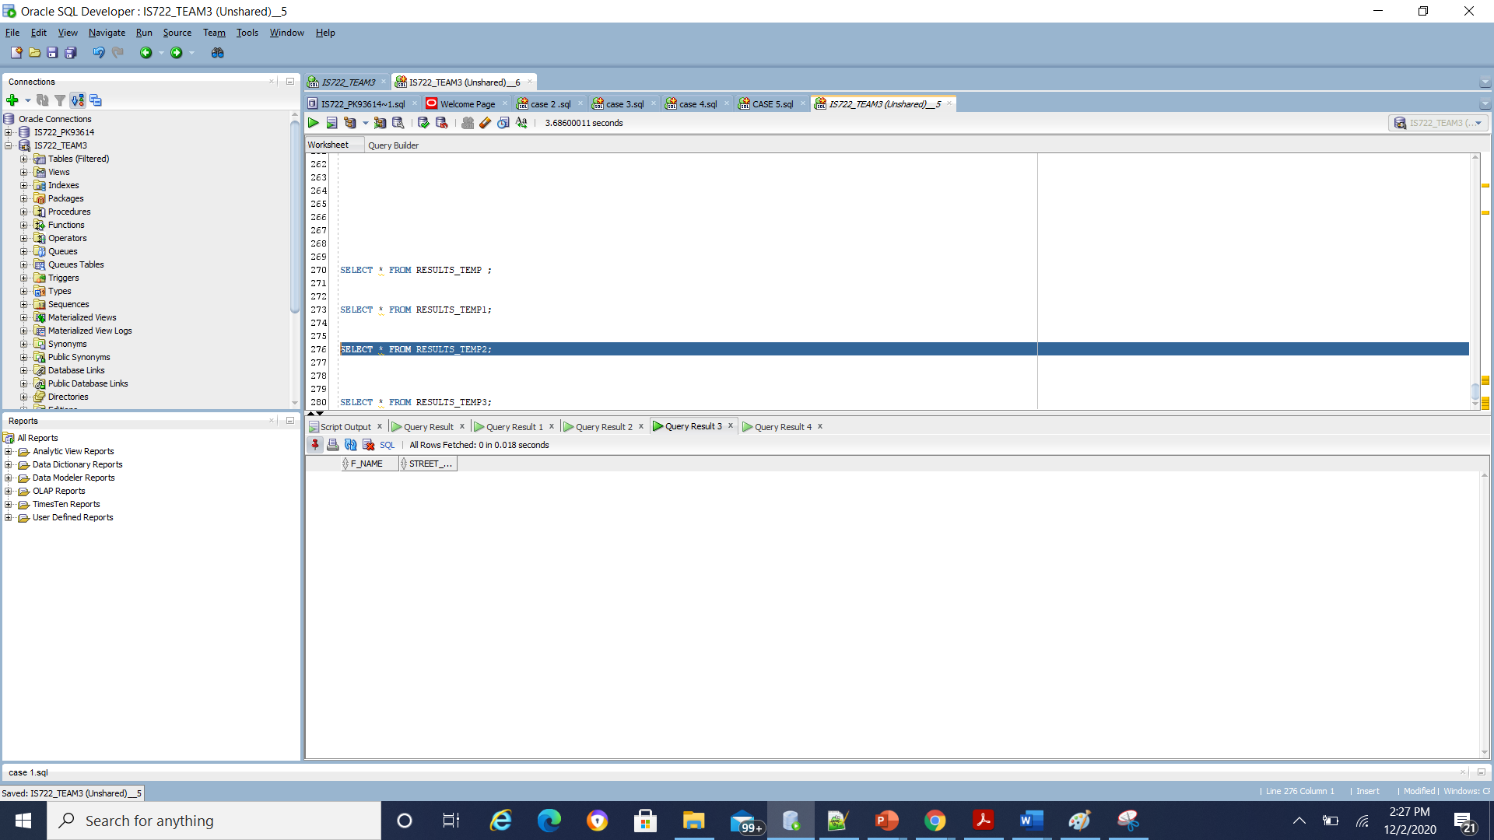

Temporary table 4:

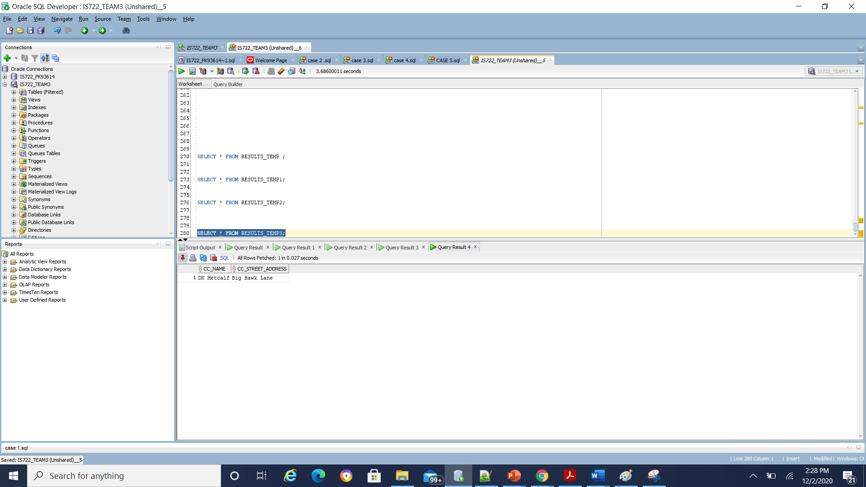

**D) CONSOLIDATED QUERY: OVERALL RESULTS:**

**Put together the results of the subqueries by using a UNION operation. Make sure you have union compatible results to demonstrate this case**

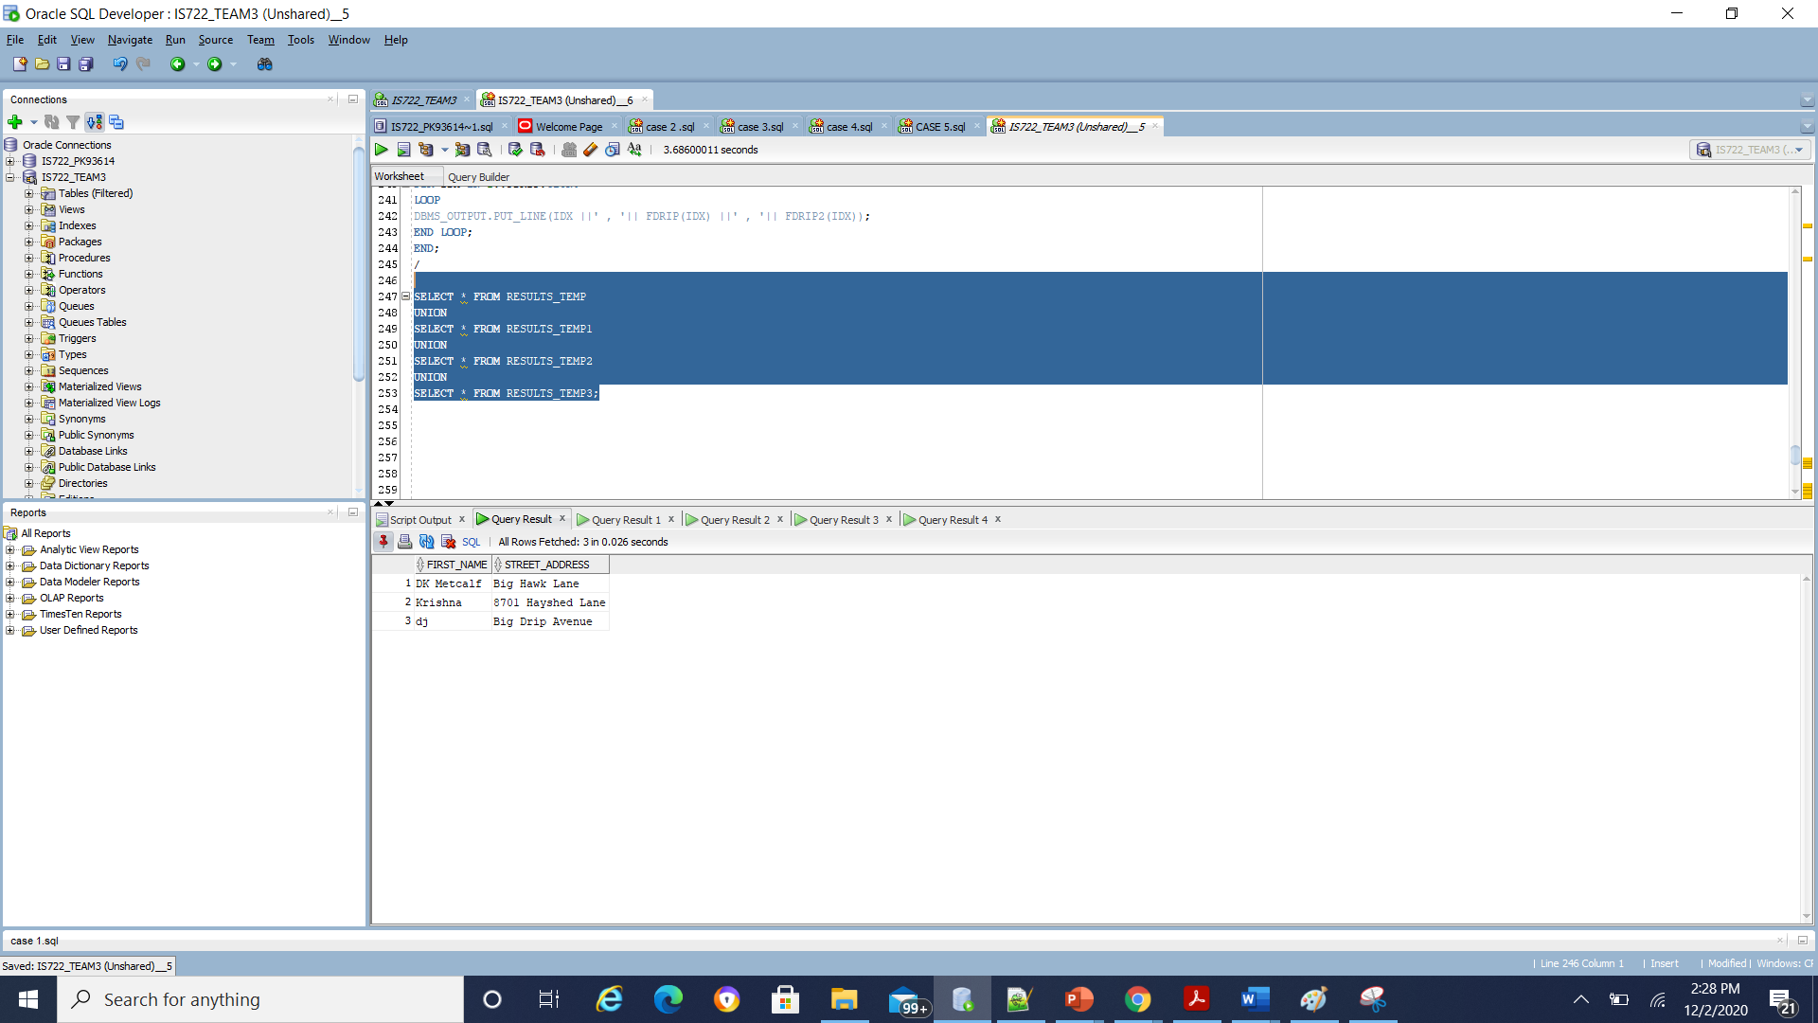

OWN SCENARIOS CREATED: EXTRA SHOW HOW GOOD OUR PRODUCT IS:

**CASE 7:**Display all titles of a particular artist where search string for artists starts with I letter :

A) GLOBAL QUERY

 'SELECT cds_title FROM cds_db WHERE artists LIKE ''l%'''; ( global query)

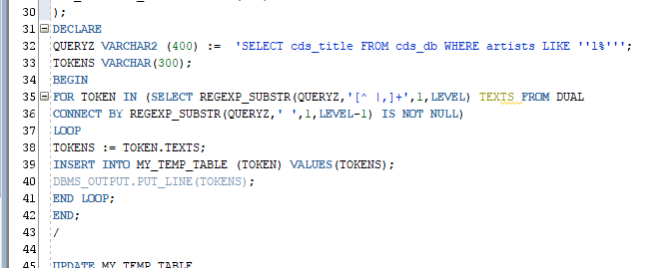

Tokenizer output:

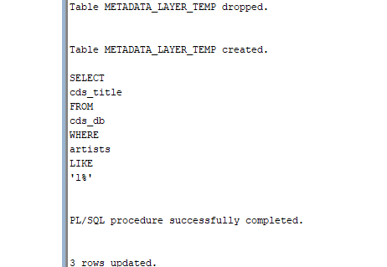

B) **SUBQUERIES OUTPUT: FROM ALL LOCAL DBS 1,2,3,4 RESPONSES**

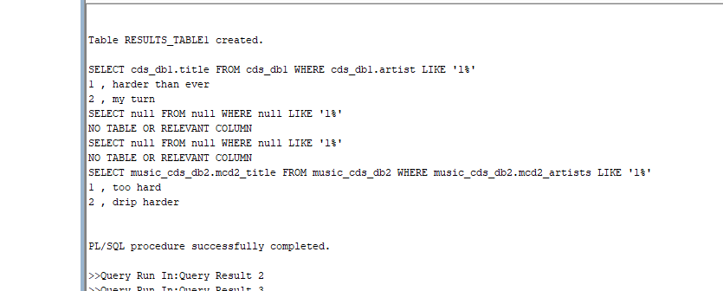

C ) PARTIAL RESULTS:

Temporary table1:

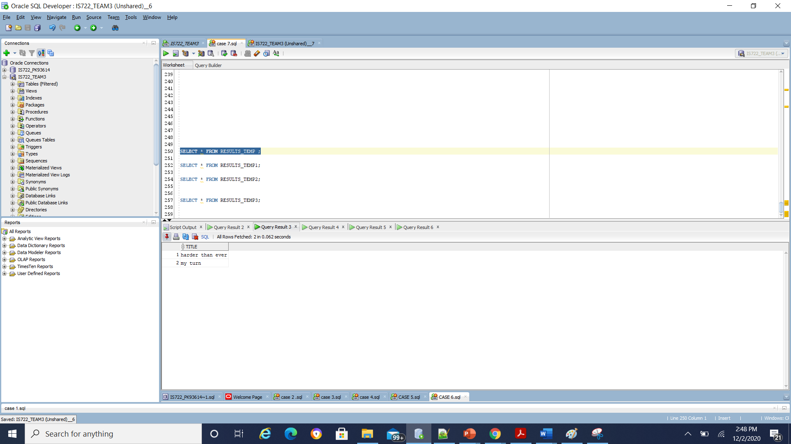

Temporary table 2:

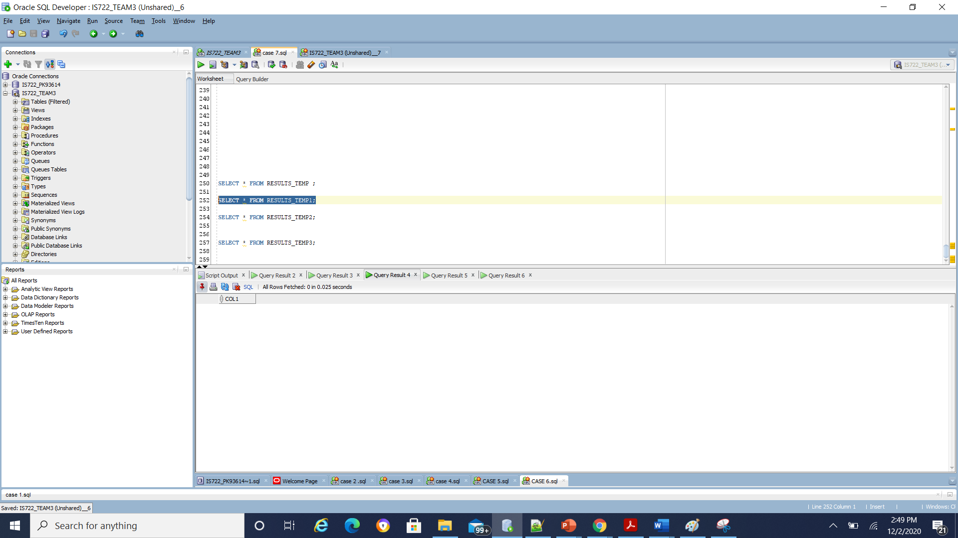

Temporary table 3:

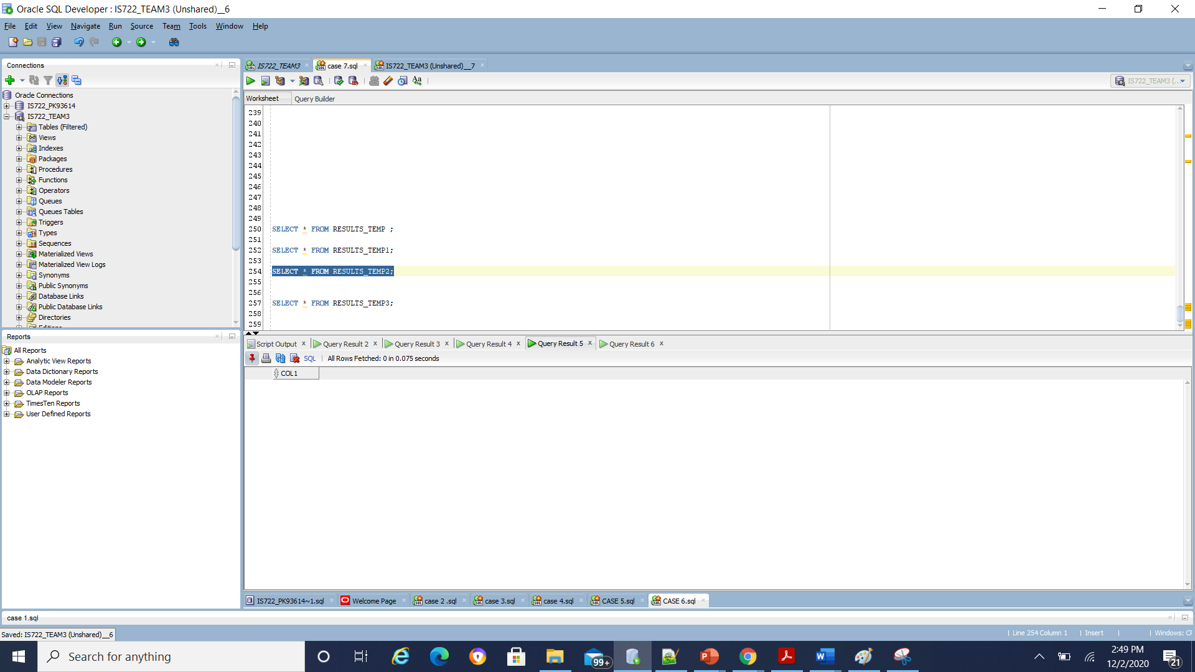

Temporary table 4:

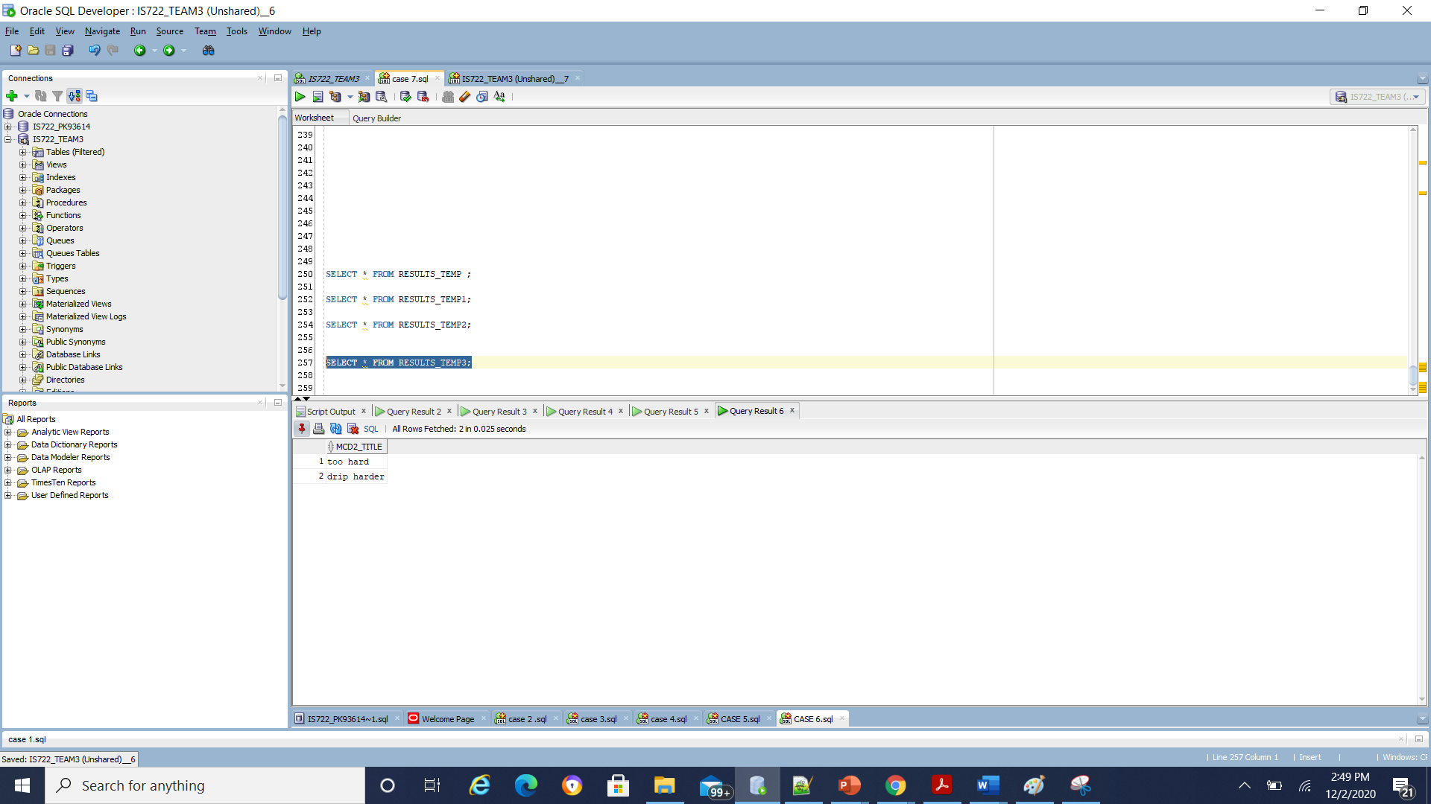

**D) CONSOLIDATED QUERY: OVERALL RESULTS:**

**Put together the results of the subqueries by using a UNION operation. Make sure you have union compatible results to demonstrate this case**

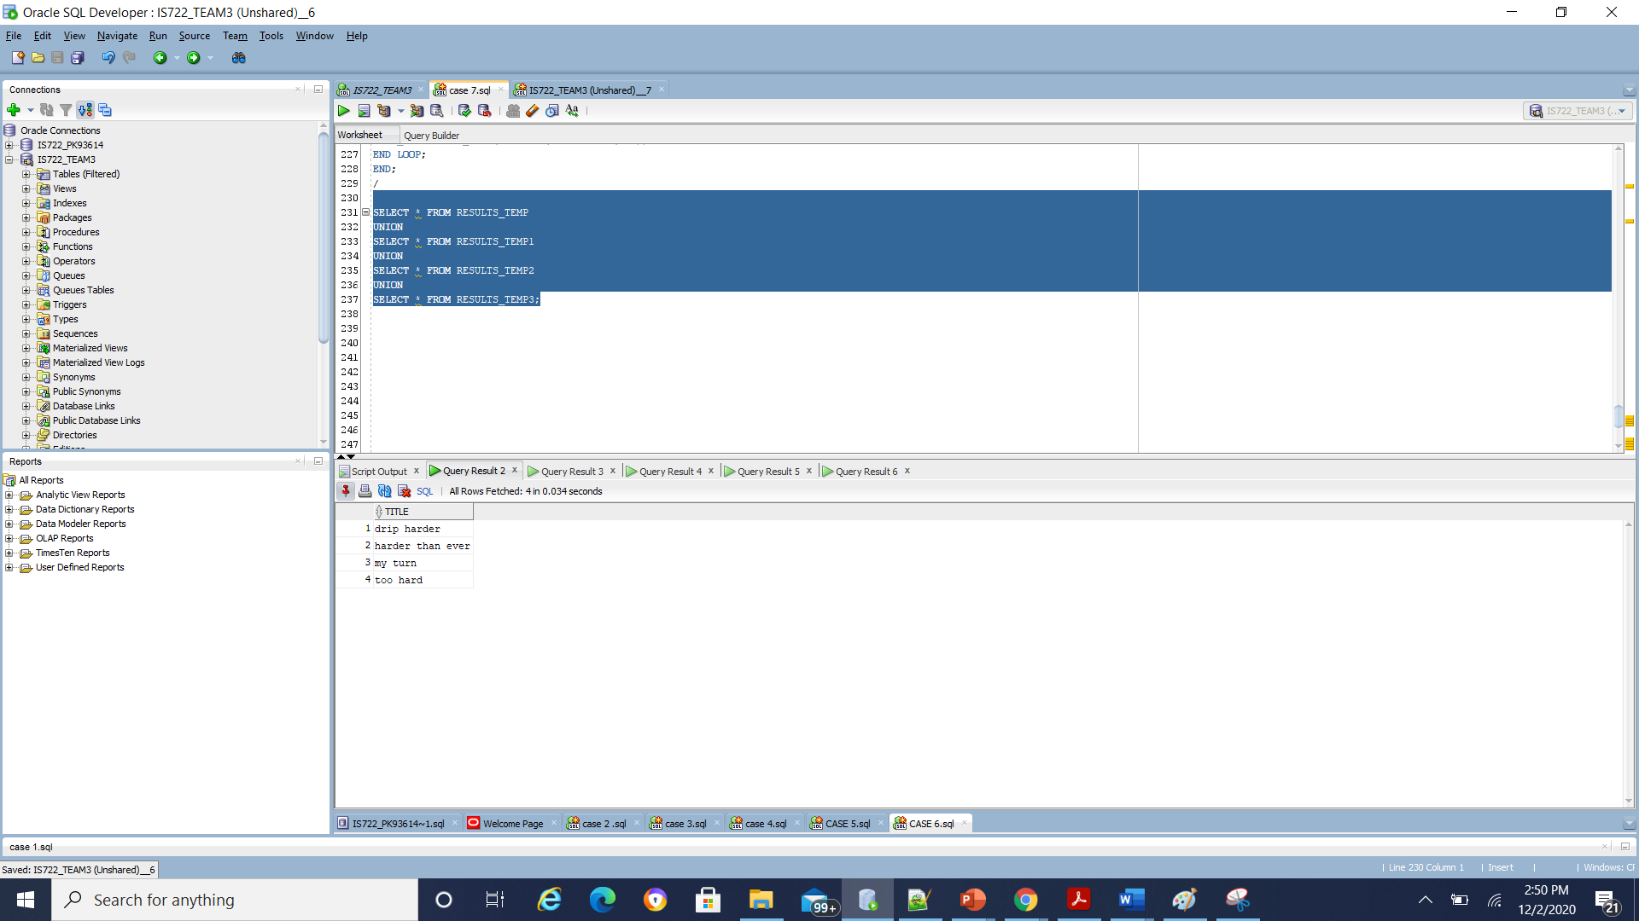

**CASE 8:**Display all titles,price of a particular artist:

A) GLOBAL QUERY

'SELECT cds_title, cds_price FROM cds_db WHERE artists = ''lil_baby'''; ( global query)

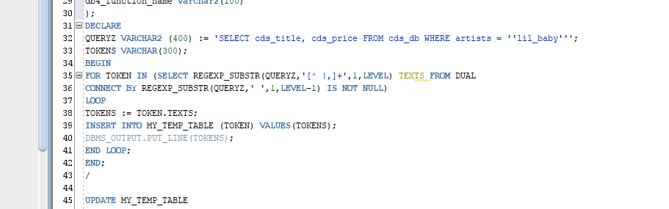

Tokenizer output:

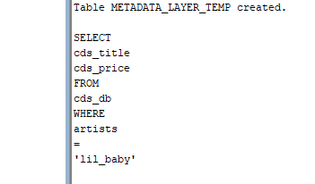

B) **SUBQUERIES OUTPUT: FROM ALL LOCAL DBS 1,2,3,4 RESPONSES**

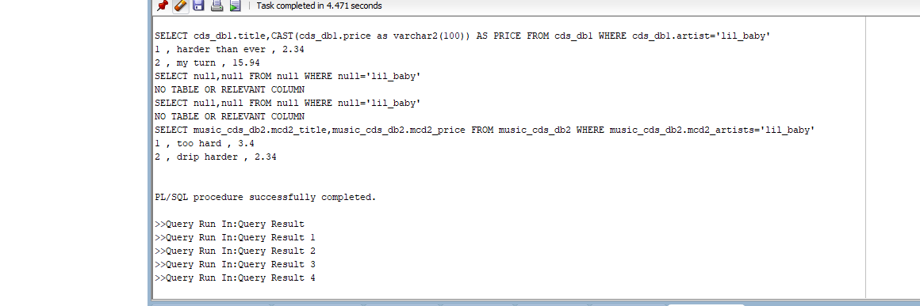

C ) PARTIAL RESULTS:

Temporary table 1:

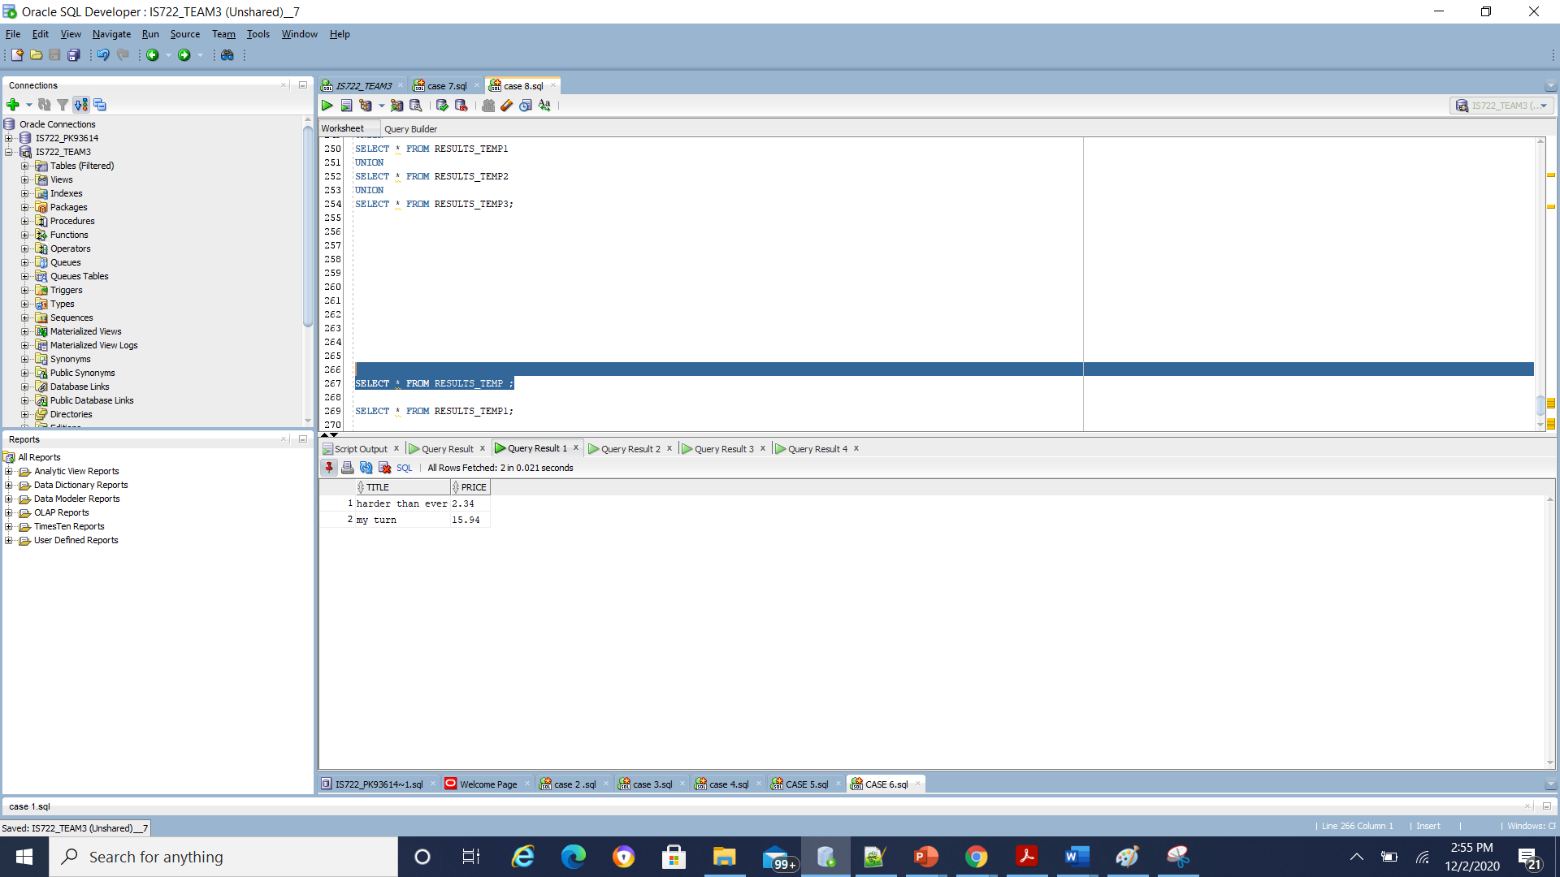

Temporary table 2:

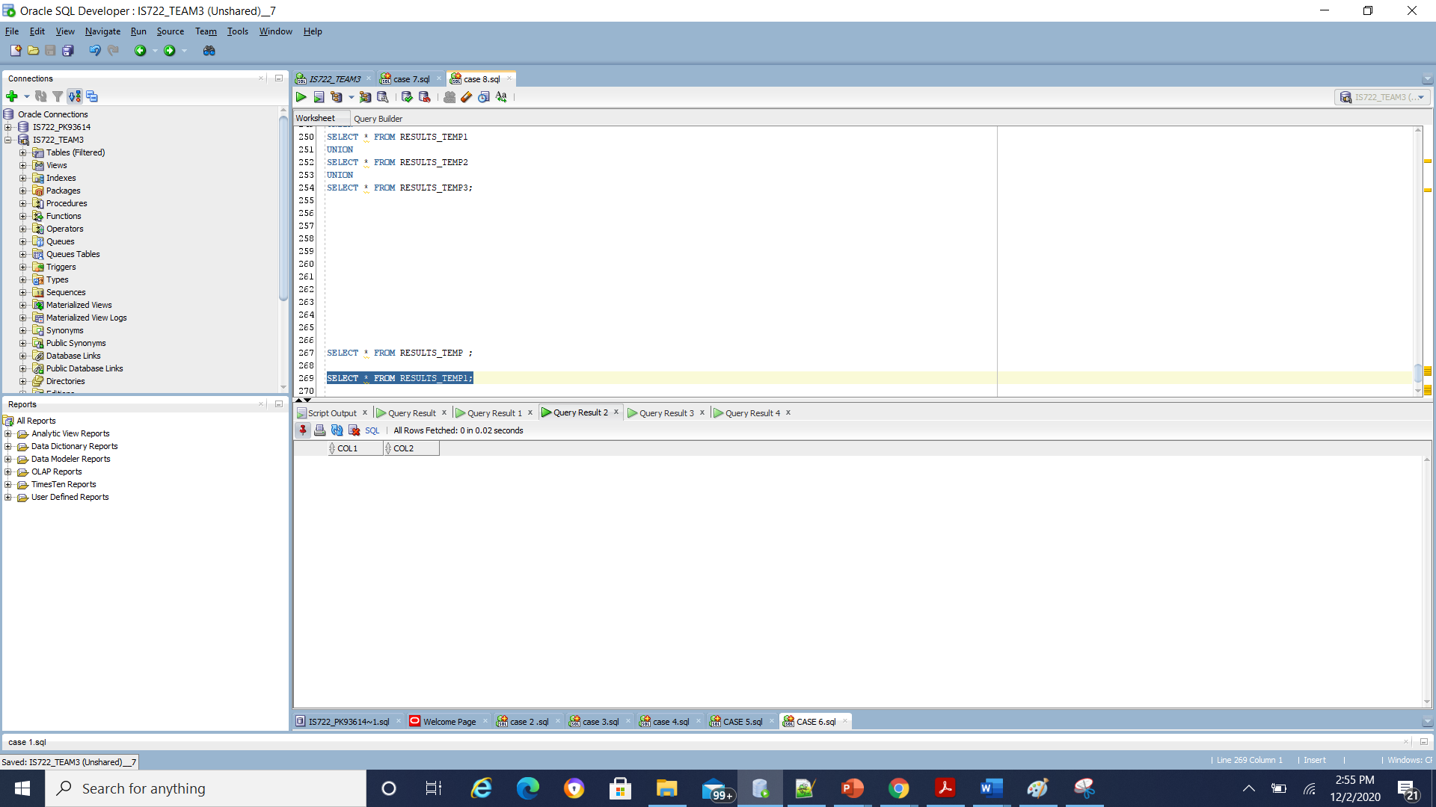

Temporary table 3:

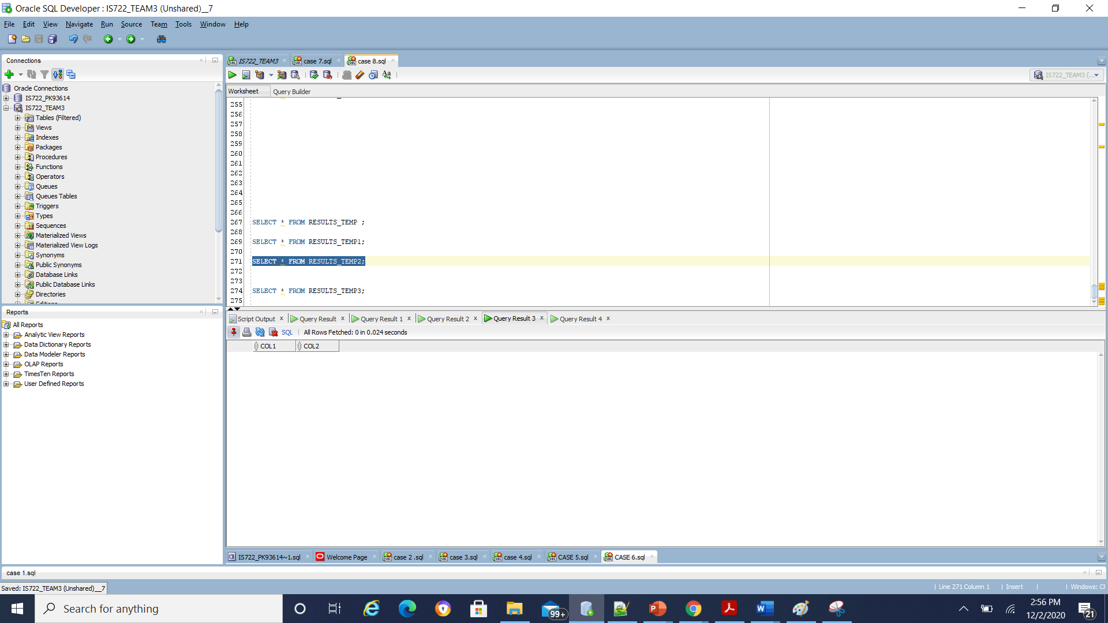

Temporary table 4:

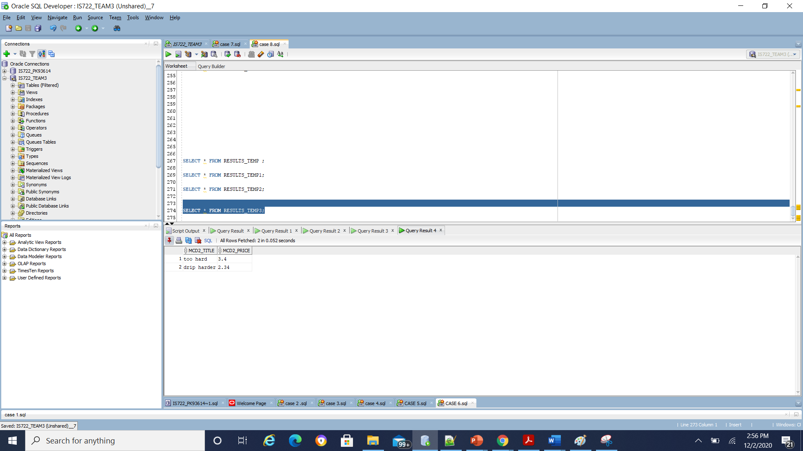

**D) CONSOLIDATED QUERY: OVERALL RESULTS:**

**Put together the results of the subqueries by using a UNION operation. Make sure you have union compatible results to demonstrate this case**

